Merely for Stress Relief

Andre Douceht

Brian Diefenderfer

Ernest Roberts

Jeff Evans

Jeremy Lanham

Robert Myers

Violence Game Design Document

Merely for Stress Relief (MSR)

**Summary:**

Merely for Stress Relief, is a game about glorifying violence with a target audience of 18+. It’s to be released on PC and used with either a controller or mouse and keyboard. The game takes place in a fictional city and landscape that features three main areas consisting of Farmland, urban neighborhoods and a bustling metropolis. Every area has different weapons and possibilities for the player to enact his fury upon the random non player characters in the game. As players continue to play they can build stat points to give themselves new skills and perks. The players character is the player himself, they are dropped in a sandbox world with overwhelming possibilities to enact violence and relieve stress on this fictional world. Every object that is seen can be used in some way to cause violence to the masses in the game. As the player progresses through their play session, the game will try and stop the player from enacting this violence on the city, either by sending the police, concerned citizens and even animals will take up arms against the player depending on who they decided to attack. The game gauges the player morality based on the npc’s the player has attacked. The different level of defense against the player escalates based on the score the player has earned through their play session. The game ends when the player is killed or captured in game or they quit. After the game is over players can choose to share replay’s of their rampage along with the audio content from their microphone with friends through the games internal replay system, also with the viewing of the players score on the global leaderboards.

**Target Audience:** 18+ M

**Genre:** Third Person Shooter, Action/Adventure

**Average Game Session:** 15 mins to 5 hrs (varying from player to player)

**Game Mechanics:**

MSR allows the player to navigate to any point in the world by climbing, running, and driving vehicles. Every object can be used by the player in some way to build their score and enact violence. Players build stat points that can be used to manipulate themselves or the actual game world. Players can also use certain appliances and buttons to cause violence.

**Game Dynamics:**

As the players score rises so does the number and ferocity of enemies that try to stop the player from causing violence and end their game. Depending on the area and position, objects and non player characters are in can change, not only the animations but also the number of points players can get. Player score also determines the amount of anarchy in the world that changes the scenery, but the way this event eventually happens is by the players morality alignment either being good or bad which also affects who is trying to stop the player and who avoids them.

**Game Aesthetics:**

MSR is a stylized medium poly game, featuring a bright colorful setting and gets progressively grittier as the players score rises. Although the overall world is calm, the players score and actions dictate the overall look of the world. The farmland area is full of crop fields consisting of corn, pumpkins and potatoes. These are huge areas that have minimal human population and a high volume of farm animals. Neighborhoods that can be found further to the center of the map have significant volumes of humans along with domesticated animals. These feature wide developed streets and a wide variety of home layouts. The metropolis features high rising buildings and tight streets and alleyways with the highest number of humans and lowest number of animals. MSR provides it’s own music but the player may opt to use their own play lists. If the player chooses to use MSR’s music then as the players score rises the music gets darker with heavier bass.

**Game systems:** PC

**Technological requirements:**

TBD

**Title/Start Screen:**

TBD

**Goal:** The goal of MSR is to score as many points as possible and relieve the greatest amount of stress before your stopped by one of the many enemies that you will encounter in the game.

**Game controls:**

* Overview-
* Control scheme- PC (All controls can be changed to the player’s preference)
  + “WASD” for moving the character.
  + “Space” to jump.
  + “L-Ctrl” to crouch.
  + “L-Click” the mouse to attack with currently equipped weapon.
  + “R-Click” the mouse to throw or push.
  + “E” is the action button. (Get in and out of vehicles, pick up weapons and items, open doors, etc.)
  + Hold “Shift” to run.
  + “Esc” for the pause menu.
  + The player can assign weapons and some skills to the number keys.
  + “I” brings up the inventory/weapons menu.
  + “K” brings up the skills menu.
  + “M” brings up the map.
  + “Q” toggles between previously used weapon and the currently equipped one.
  + “R” reloads current firearm.
  + “F” to grab people.

**Screens:**

* Title Menu- consists of the Single player, options, leaderboards, and replay
* Pause menu (Player can see their current stats as well as access the options, save their game, load their saved games, inventory, map, and quit)
* Loading Screen - Displays information about levels of anarchy in areas, such as riots by using a set of infographics that are made as the player is playing the game.
* Map - The world map is split into components: Farmland, Urban, and Metropolis. Each area is open and expansive with no clear pathways that the player must follow. The map uses North, West, East, and South markers to keep the player from getting lost, in addition to landmarks and special names for areas.
* Inventory - choose from available weapons and items picked up through the world
* Options screen
  + Audio (change audio levels)
  + Video (adjust graphic settings, gore level, adjust gamma)
  + Extras (Profanity filter, model viewer, sound stage, replays)
  + Gameplay (keybindings, look sensitivity, invert controls)
* Single player menu
  + Choose between Sandbox and time trial mode

**Modes of Play:**

* Sandbox/classic - Intended game mode, infinite time to play and relieve stress and build points.
* Time Attack - Players have 30 minutes to score as many points as possible. the countdown clock pauses when players are in a HUB or in a menu.

**Map sections:**

* Neighborhood - A rural suburban area with domesticated animals and a moderate number of people.
* Farmland - Wide open fields and farmland, filled with wildlife and farmers.
* Metropolis - A bustling metropolis filled with citizens and police, players will find the highest amount of action here.
* Hubs - Hubs are special locations where the player is safe from the environment and can only interact with the environment minimally - players cannot gain any score increases or increase their brutality scale while inside a hub. Each component of the world has a single hub and players can choose to transport to the hub of the area they are in if they get lost or want a break. Transporting to a hub is only available if the player is not in combat. The game will notify the player what is and what is not a hub by labeling it with a special icon on the radar.

**HUD System:**

* Default HUD- when the player is walking or running. (1st person view)
  + Health bar in the upper right hand of the screen..
  + Radar set in the bottom left, shows enemies and friendlies
  + Current equipped item or interacting with in the bottom right, if a firearm is equipped than an ammo counter is displayed.
* Vehicle HUD- when the player is driving a vehicle. (Can switch between 1st and 3rd person)
  + Includes the speedometer in the bottom right of the screen, along with the vehicles health.
  + Radar is stays in the bottom left hand corner

Pl**ayer Character:**

* Name- Players choose the name for their character, although no NPC will say the Player Characters name.
* Appearance-
  + Customizable Top, bottom, accessories and facial features.

**Player metrics:**

* Movement - Movement speed and jump height/distance increase as brutality increases. Players can switch between walking and running. Running and jumping get more negative attention from environment.
* Navigation - All terrain is navigable. Some areas can only be reached with high amounts of run/jump stat, or with a particular vehicle.
* Hoist/hang

**Stat and XP System:**

* XP Bar
  + XP Gained is equal to the base points of NPC’s you put in a incapacitate state.
  + Starts at 50 points then ramps up by 25 after every level (ie level 1 is 50 points, level 2 is 75 points)
* Stat points
  + Gained when XP bar is filled
  + Stat points may be saved
  + Stat points are used to upgrade and unlock new stats.

**Player skills:**

* (Name of skill)
  + Description
  + Skill modifiers
  + Player metric
* Throw Weapon 1-3
  + This skill allows the player to throw their equipped weapon at enemies and NPCs.
  + The more points put into this skill, the bigger and heavier the weapon able to be thrown.
  + At level 3 the player chooses either Boomerang Weapon or Kunai Chain.
    - Boomerang Weapon allows the user to throw their weapon and it returns to them.
    - The Kunai Chain skill allows the user to pull enemies back towards them.
* Iron Fists 1-3
  + This skill increases damage done by the player’s bare hands.
  + The more points put into this skill, the more damage bare handed attacks do.
  + At level 3 the player chooses either Bronze Fists or Jab.
    - Bronze Fists increases the player’s barehanded damage even more.
    - Jab increases the speed of the player’s barehanded attacks.
* Slow Motion 1-3
  + This skill enables the player to slow down time for an advantage over NPCs as well as being able to see their carnage in slow motion.
  + This skill starts out lasting 15 seconds and increases by 5 seconds per point into the skill.
  + At level 3 the player chooses either Reverse Time or Stop Time.
    - Reverse Time allows the player to rewind time.
    - Stop Time allows the player to completely stop time and still be able to move around the game world.
* Expert Driver 1-3
  + This skill increases the handling of vehicles as well as giving them nitrous.
  + Each point into this skill increases the duration of the nitrous.
  + At level 3 the player chooses either Remote Control or Personal Vehicle.
    - Remote Control allows the player to remotely control vehicles. Even vehicles being manned by NPCs.
    - Personal Vehicle allows the player to call a personal vehicle of their choice to their position.
* First Aid 1-3
  + This skill enables the player to partially heal themselves with a push of the button. To keep the skill from being overpowered, the skill cannot be used again until 2 minutes have passed.
  + The skill starts out healing the player by 20% then increases by 15% per skill point.
  + At level 3 the player chooses either Circle of Life or Health Boost.
    - The Circle of Life skill replenishes the player’s health over time.
    - Health boost vastly increases the maximum health of the player.
* Fitness
  + This skill increases the speed and jump height of the player.
  + As the player increases this skill, their running speed and jump height increase as well.
  + At level 3 the player chooses either Mach Speed or Jumpman
    - The skill Mach Speed allows the player to reach an incredible amount of running speed after a few moments of running.
    - Jumpman allows the player to jump extraordinary heights allowing the player to climb buildings.

**Power UPS and state modifiers:**

* Powerups can be found throughout the game world.
* Invincibility
  + Player cannot take damage
  + Lasts for 30 seconds
* Speed Boost
  + Player movement speed is doubled
  + Lasts for 30 seconds
* Damage Multiplier
  + Damage done to npc characters is doubled
  + Lasts for 30 seconds

**Health:**

* Health in General
  + Displayed as a HP bar
  + Health kits found around the map, and First Aid Skill allows players to restore health.
  + Players screen enters a bleed out phase that obscures vision and causes a heartbeat sound effect.
* NPC health
  + Every NPC has a hp bar have varying sizes depending on the NPC
  + If a NPC’s hp bar gets to within 10 points of their hp bar from being emptied they will enter a incapacitate state where they can do no more actions and the player can choose to leave them or finish them off for extra points.

**Scoring:**

* Point value system with a multiplier that changes based on how brutal, your attacks are.
* Brutality Bar
  + Depending on how brutal a npc dies will give a multiplier of, x1, x2, x3, x4, x5, x6, x7, x8, x9 or x10.
* Leaderboard setup
  + Image
  + Leaderboards are split between time attack and sandbox mode.
  + Leaderboard is organized by highest scores, but can be organized by Time played, Most used weapon, and Highest amount of damage caused in a single blow.
  + When players view the leaderboards they can click on a persons profile to see the overall stats of that player.
* Achievements
  + List
  + Icon Images
* Hardcore Domestication
  + Kill 500 Animals
* Fighting the Man
  + Kill 500 Law Enforcement
* Decreasing the Surplus Population
  + Kill 500 NPCs
* Variety is the Spice of Death
  + Use 10 different objects in the environment to inflict violence on something
* Vigilantly Violent
  + Kill 500 Gang Members
* Make it Rain
  + Cover yourself completely in the blood of your enemies

**Vehicles (More TBD):**

* Players enter vehicles by pressing E or the hotkey they bound to the “enter vehicle” section of the keybind menu.
* Vehicle type overview- Luxury, Work, and Special
* Vehicle to world interaction
  + Vehicle description
  + Image of vehicle
* Tractor
  + Work
  + Farmland
  + Can drag other vehicles
  + Max Speed: 20 MPH
* Forklift
  + Work
  + Farmland
  + Can lift objects and NPCs
  + Max Speed: 20 MPH
* Dirtbike
  + Special
  + Urban Neighborhood
  + Good at traveling across rugged landscapes
  + Max Speed: 150,000,000 MPH
* Skateboard
  + Special
  + Urban Neighborhood
  + Good airtime
  + Max Speed 10 MPH
* Police Car
  + Luxury
  + Metropolis
  + Good at attracting attention
  + Max Speed: 180 MPH
* Limo
  + Luxury
  + Metropolis
  + Good at being a waste of space
  + Max Speed: 150 MPH / chance of crashing into a wall because car is too damn big

**Universal game mechanics:**

* Portal mechanics
  + Doors can be dead bolted, and regular turn and key, every door is operable and allows the player to enter any building.
* Breakable objects
  + When an object receives enough damage it will break and cannot be repaired.
  + Objects such as crates or machines will yield items that were labeled on the outside of the box.
  + Some objects like red barrels, fire extinguishers and the like will provide necessary effects and damage to surrounding characters and objects.
* Non-breakable objects
  + Non-breakable objects in MSR, include the large structures and buildings that can only be damaged via specific NPCs or events from the players score getting to high.
* Morality choice
  + The Player chooses how and who to enact violence on, players can opt to focus on evil doers to maintain a good/vigilante alignment or focus on every npc for a evil alignment.

**Universal System and Ruleset (For concept only):**

* Dynamic NPC reaction
  + Depending on who the player focuses to the enact violence on the most, NPC’s will either run in fear or try and stop.
  + Citizens if they believe are in large enough group will eventually attack the player if they have an evil alignment.
  + Law enforcement will ramp up eventually involving an army to take down the player.
  + If players have a good alignment civilians will run in fear and law enforcement will attempt to apprehend you, while the npc’s you have been focusing on will call in their own army to stop you.
* Player score dictates change
  + As the player builds their score higher and higher they city’s civility will begin to crumble and may even cause full blown riots and anarchy.

**Non-player characters (More characters TBD):**

* NPC type overview- Animals, Citizens, Lowlife and Law Enforcement
* Difficulty Scale- Base difficulty of NPC increases with number
* Character list
  + name, sex, age
  + Background material
  + NPC type
  + LEVEL where encountered
* Dog
  + Animal
  + Urban Neighborhood
  + Armed with Teeth
  + Base Points: 3, Base Difficulty: 1
* Cow
  + Animal
  + Farmland
  + Armed with Moo (Alerts Farmer)
  + Base Points: 2, Base Difficulty: 1
* Bull
  + Animal
  + Farmland
  + Armed with Horns
  + Base Points: 6, Base Difficulty: 2
* Farmer
  + Citizen
  + Farmland
  + Armed with Farm Tools
  + Base Points: 5, Base Difficulty: 2
* Neighbor
  + Citizen
  + Urban Neighborhood
  + Armed with Fists
  + Base Points: 3, Base Difficulty: 1
* Commuter
  + Citizen
  + Metropolis
  + Armed with Briefcase
  + Base Points: 3, Base Difficulty: 1
* Hobo
  + Citizen
  + Metropolis
  + Armed with Environment (any objects nearby)
  + Base Points: 6, Base Difficulty: 2
* Gang Member
  + Lowlife
  + Urban Neighborhood
  + Armed with Firearm
  + Base Points: 6, Base Difficulty: 2
* Policeman
  + Law Enforcement
  + Metropolis
  + Armed with Firearms
  + Base Points: 6, Base Difficulty: 2
* SWAT Team
  + Law Enforcement
  + Metropolis
  + Armed with Military-Grade Firearms
  + Base Points: 9, Base Difficulty: 3
* Interacting with NPCS
  + Dialogue
  + Collision
* NPC rewards

**Music and SFX:**

* Section specific music
  + Farmland music - when traversing the farmland players are normally greeted with more ambience but gentle and easy going music.
  + Neighborhood music - A combination of jazz and rock tracks to get the player moving through the area.
  + Metropolis music - Fast paced, full of techno and heavy bass meant to give the player a feel of just how big the city is and the opportunities await.
  + HUB music - Catchy elevator music, sort of a calm place for the player to save and take a break.
  + Anarchy music - If the player score gets too high then this music will begin which will bring a sense of dread and alertness to the player.
  + Combat music - Fast paced and dynamic to violence on screen, (IE using a blunt weapon may cause a deeper base in the next few notes in the music.
* General sound effects
  + screams of agony
  + screams of rage
  + Police sirens
  + gun shots
  + slicing
  + fire crackling
  + explosions
  + NPC dialogue
  + car alarms

**Weapon types:**

* Sharp objects- Anything with a blade, butter knife, machete, hook, etc.
* Blunt objects- Brick, Bat, 2x4, steel chair, etc.
* Hand to Hand- Strangling, fist fight, submission holds, etc.
* Firearms- Guns, pistols, shotguns, assault rifles, etc
* Explosives- Grenades,Pipe Bombs, C4, Molotov Cocktail, RPG, etc
* Environmental- Anything that is reliant on the the environment throwing off buildings, dragging along the ground, smashing against buildings, etc
* Vehicles- Anything with a motor Tractor, Lawn Mower, Car, Skateboard, Tanks

**Collectables:**

* To entice the player to explore
* To increase score
* Golden weapons- Golden versions of same weapon types and are very hard to find in the game and give a one time score bonus when either found or used.
  + Golden Sharp Objects- Some NPCS have golden sharp objects in order to gain score and collect them the player just has to pick them up.
  + Golden Blunt Objects- Found throughout the game world these objects are fragile and one time use but upon being used the object is placed in the players collection and they are awarded an additional x10 multiplier to score.
  + Golden Hand to Hand- These are like Golden moments, when the player does a very specific action in hand to hand combat, they are given a score bonus.
  + Golden Firearms- Found throughout the game world these firearms for display only and give a one time score boost.
  + Golden Explosives- Found throughout the game world these objects are fragile and one time use but upon being used the object is placed in the players collection and they are awarded an additional x10 multiplier to score.
  + Golden Environmental- Players will sometimes find golden painted versions of environmental objects, such as a car that shines gold or a window frame that is golden highlight, and when the player enacts violence on a npc on these objects they get a x20 multiplier.
  + Golden Vehicles- Very special vehicles that give an extreme amounts of points when driven.

**Peripherals/Extras:**

* Nerf Controller- A controller that is custom made for the game, the exact layout/platform is TBD but the main feature is the handles which have been replaced with stress balls and have two buttons in the handles, so to activate them the player must squeeze the handles.

**Screenshots**

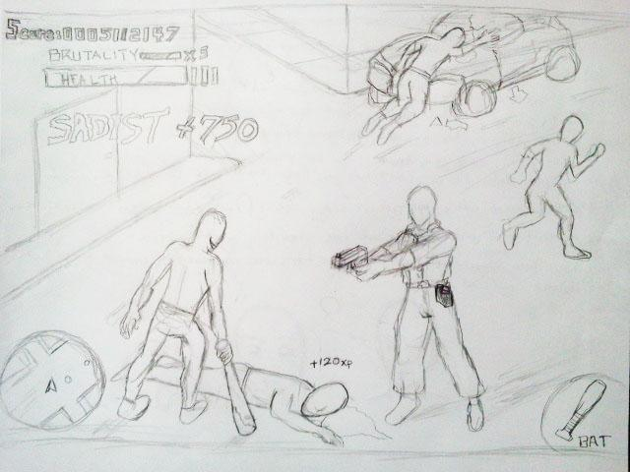

**Gameplay of MSR**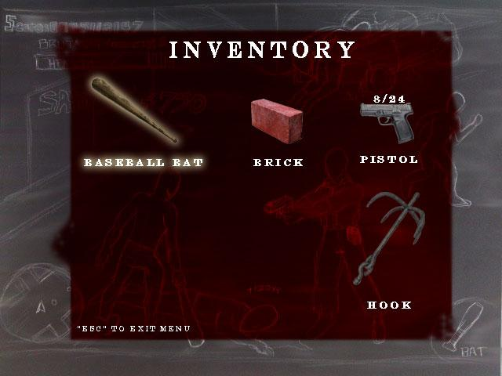

**Inventory Screen**

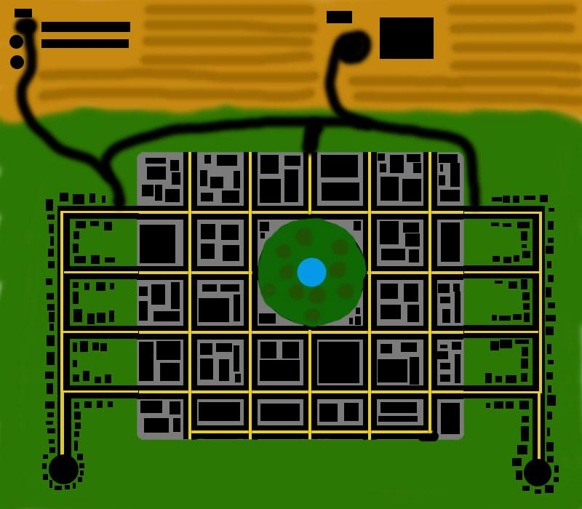

**Idea for a map of the game world.**

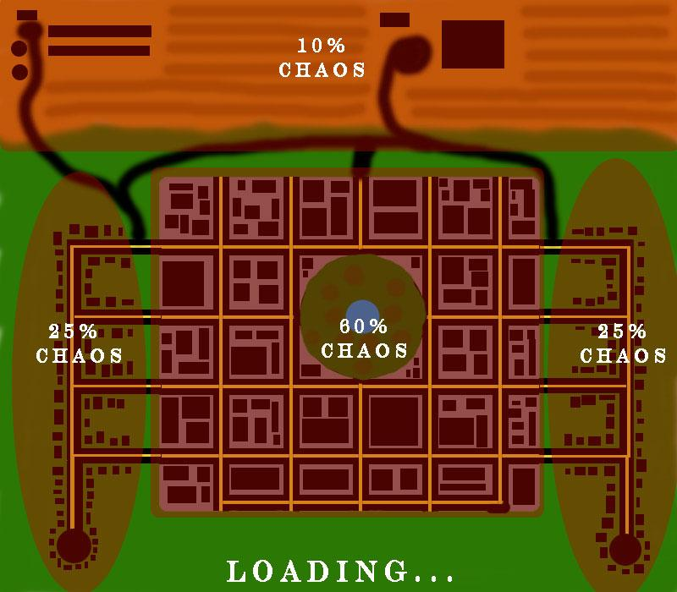

**Loading screen...**

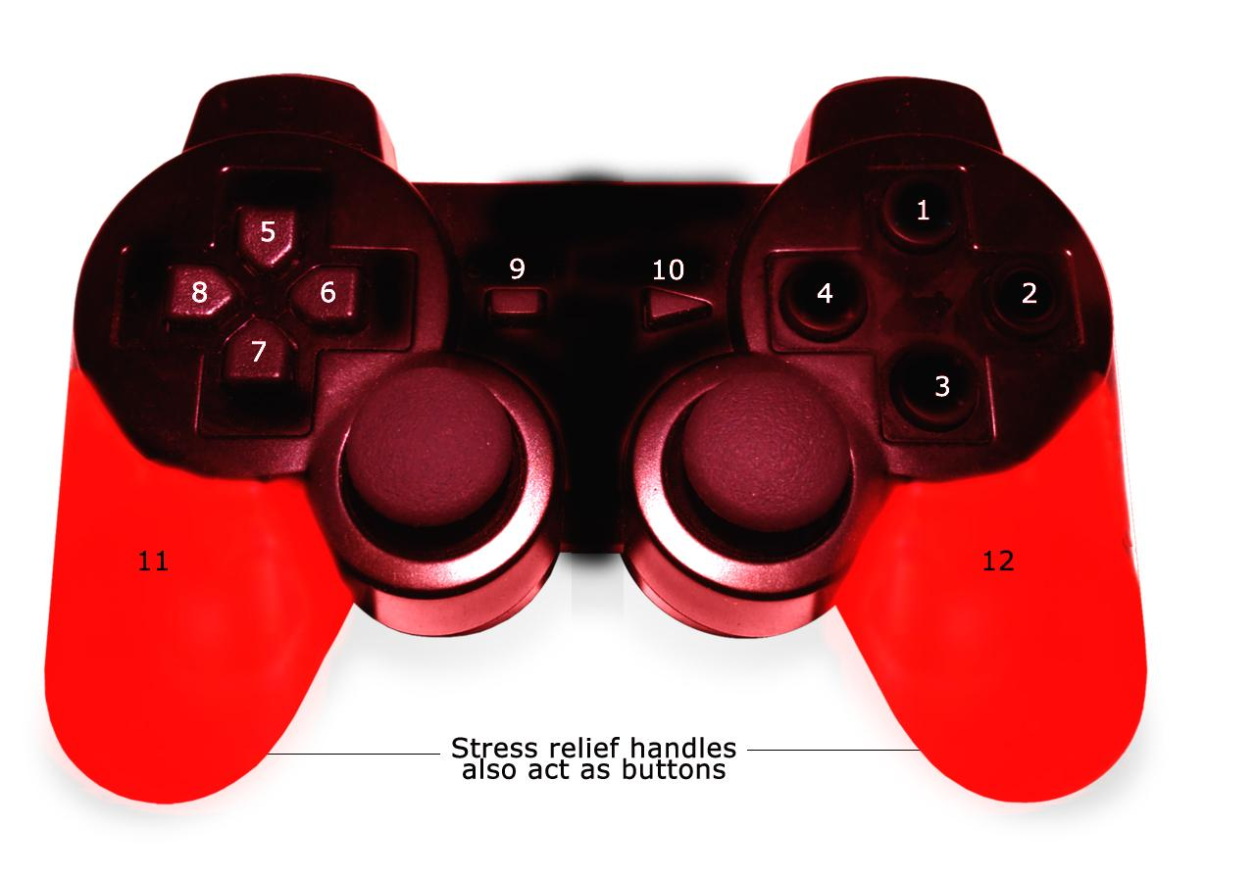**Nerf controller concept, aka a modified dual shock 2.**

**MSR Main Menu Concept.**

