Political Agenda

CREATED BY:

Ernest Roberts
Jeremy Lanham
Andre Douchet
Robert Myers
Brian Dieffenderfer
Jeff Evans

Summary- Political agenda is a game for 2-4 players competing in the presidential election involving the, republican, democratic, Greene and libertarian parties. The game is meant to give players the view of different situations and events that a politician may face during a campaign race. Players will use different actions to build themselves as the best possible candidate in 52 turns at which point following the electoral college players will calculate how many electoral votes they have with the greatest number being the winner. As players play the game they must use different actions involving mudslinging, addressing issues, rallying support and advising to gain the hearts and minds of the citizens in the states. Players will have event cards drawn every 5 turns as to try and change the election, gain money or help the players. If there are three or four people playing, players are eliminated when they do not have enough campaign funding to continue who ever is last standing at turn 52 will calculate there electoral votes and whoever has the most wins.

Target Audience- Political agenda target audience is any one 16 and above.

Time to completion- Games vary based on players but, a normal game should last between 30 minutes to a hour.

Number of players- two to four

Game Mechanics
Political Agendas main mechanic is it's campaign funding system, in which every action and movement costs a fix amount of money that can be changed based on events. These events are random based on a event card deck that is reshuffled after every event card drawn.

Game Dynamics
Political Agenda constantly changes from not only random events but, from also players choices when trying to win states. The events that can take place can either give players extra money at the cost of their image or help improve themselves as a candidate.

Game Aesthetics
The Aesthetics for Political agenda is meant to give the players a clear view of who is the most popular in which state, while being easily accessible. The game board is a regular cut out of the united states with topological features based on actual height maps of North America with a color scheme outlining the different regions of the United States. There are also small holes in every state in which players can place their pegs to represent their popularity, if the holes in the states become filled pegs will have holes in the top of them in which pegs of the same color can be stacked on top of each other. The aesthetics of the game are meant to make players think about there strategy and the urgency of having the popular vote in key states.

Game rules and systems

Rules
1. Player stats are between one and fifteen,
2. Players can choose to increase two stats from zero to one, or increase one by two at the beginning of the game
3. Players can see each others stats unless starting in the south
4. Players playing as the yellow libertarian party or the green candidates change there home state into their corresponding party by removing any pegs that are automatically assigned to that state and placing one of their color in it.
5. Players do not have to do an action when they move to another state.
6. Players receive $50,000 for every state that they have majority rule in.
7. Several states must begin the game with one peg in them following the list below:
Democratic: Maryland, Delaware, Pennsylvania, New York, Vermont, Maine
Republican: Texas, Oklahoma, Arizona, Louisiana, Alaska, Mississippi, Alabama
8. Players must keep track of their stats the whole game, if a player starts in the south then they must keep their stat card hidden.
9. If any player runs out of funds or does not have enough funds to perform an action for two turns they must remove their pegs from the bored and lose.

Stats

Players have three main stats:
Charisma - How well the player presents his speeches.
Image- Overall/How an individual state see's you.
Intelligence- Ability to come back from mishaps/mudslinging.

Along with the stats players are also given a campaign fund and must keep track of state alignment that is represented by pegs that stack on top of each other.

Beginning the Game

1. Players take turns in alphabetical order or from oldest to youngest.
- When a player has been chosen to go first they must draw a card from the deck of state cards to see where they were born/where they begin their campaign, the deck is then reshuffled after every drawn card.
- Players get a bonus for starting in different regions which are followed along with different amounts of campaign starting funds:

Northeast: +1 Increase to Intelligence, $500,000
South: Hidden stats until turn 50, Lowest Campaign Funding, $250,000
Midwest: Highest Campaign to Funding, $750,000
Southwest: +1 Increase to Charisma, $500,000
West: +1 Increase to Image, $500,000

- Once all players have their starting states they may receive there campaign funding.

Players Turn

1. The player gets to choose to either campaign in their home state or move to a new one. It costs $10,000 to move from one state to state, they may visit the same state more then once.
2. When players decide on staying in their home state or moving they can choose from one of the four actions below:

Mudslinging: Opponents Image-mudslinging players charisma= Opponent loses Image
-$50,000
Players can choose to either take two pegs from a chosen players popularity from the state they are in or remove one peg from every player on that state.

Addressing issues: Intelligence+Image=Increase to Charisma
-$100,000
2 pegs in state

Rally: Intelligence+Charisma=Increase to Image
-$175,000
3 pegs alignment in state

Advising: Plus 1 to Intelligence
-$100,000
Keeps the same

    - After an action has been completed and funds removed for it, the next player may take there turn.
    - This set of steps continues until 50 turns have been taken when the special events called debates are going on. A turn is when all players have made an action.
    - When a player can not afford his campaign anymore then they are eliminated and all of their pegs are removed from the bored.
    - After turn 52 while following the electoral colleges set number of points per state all players calculate how many points they have based on whether or not they have the popularity a state.

Events

Every 5 turns a player draws an event card, plus a state card is drawn, both cards remain on the board until a new set is drawn, players may only reap the benefit of an event once and only once:

- First the Event Card is drawn.
- State card is drawn.
- Players can choose to utilize the Event for themselves or ignore it.
- After all players go through there turns the state card is reshuffled and the event card goes to the side, and the event deck is reshuffled before the next event.
Special Actions/events:
- Players must hold conventions on turn 26, for free in the state of their choice which give a plus 5 pegs to that state for their color.
- Players are required to take place in a debate at turns: 50,51,52. The debates take place at 3 states drawn from the state deck on turn 50. Whoever wins the Debate gets 5 points to there side in the state, winner is the player with 2 higher stats then his opponent, if the debate is taking place in a state with a majority of pegs to the a corresponding players side then that player gets a plus 3 to all of his/her stats.

Event Cards

All event card bonus's are additive onto normal action benefits. Events are split into three categories; funding opportunities, tragic events and celebratory events.

Funding opportunities

1. Guest actor on New blockbuster hit!

The current leader in peg count in (insert state here), is asked to guest star in the latest blockbuster hit for $100,000 the doing so decreases your image by 4 but you also gain 1 charisma.
If this card is ignored gain 4 image.

2. Billionaire invites you to a yearly exclusive party at his Mansion in (insert state here).

Take Bribe from Millionaire's- Charisma x $100,000, -4 image
Reject Bribes- Increase Image by 2
Just talk- +1 Charisma

3. Corporation offers to fund your campaign and a Rally if you visit (insert state here) on your next turn.

$250,000 is given to your campaign if you hold a rally.

4. A Fundraiser in (insert state here) has just completed and they would like to help fund a candidates campaign.

$50,000 awarded to player with majority of pegs in the state.

Tragic Events- Events that drain players money but increase, stats.

1. School Shooting at (insert state here) College.

Hold a Rally in the state next turn for 2 times the cost, plus 4 image
Mud sling opponent on your next turn, lose the same amount of image as your opponent but decrease the alignment in the state by times 2.
If neither player acts on this event they both get -1 Image.

2.Terrorist attack at (insert state here).

Both players must be in the state on their next turn and gain Charisma based on the amount of money they use.
$100,000-plus 2 image
$200,000-plus 2 image, plus 1 charisma
$300,000-plus 4 image, plus 2 charisma
$400,000+-plus 1 image for every $100,000 and plus 2 charisma

3. Oil Spill at (insert state here),

Send $250,000 to assist the state in cleaning up the spill, plus 5 image
Send $125,000 and assist in cleaning up the state, plus 5 image and plus 2 intelligence but skip your player action.
Ignore the event, -1 Image

4. Protest against (insert state here) government.

All transportation into the state is blocked so no player can enter the state on their turn.
If a player is in the state of this event they cannot move on their next turn and/or address the issues of the protest to increase image by 2 at two times the cost of addressing issues.

5. Hurricane
Draw two more state cards along with the required one.

All actions in these states cost x5 more then usual.
Hurricane batters, (insert state here), (insert state here) , (insert state here), Players may move to help the states by holding a rally to boost morale. The rally is two times more effective then it normally is.

6. Tornado

All actions in these states cost x5 more then usual.
Tornado devastates, (insert state here), Players may move to help the state by holding a rally to boost morale. The rally is two times more effective then it normally is.

7. Flash Flood

All actions in these states cost x5 more then usual.
Players cannot enter or leave the state until there next turn, but all actions taken increase Image by 8.

8. Earthquakes

(insert state here) has just gone through a earth quake

Players cannot leave the state but may enter,
All actions in this states cost x10 more then usual but yield x2 bonuses.

9. Snow Storm
Draw two more state cards along with the required one.

In a freak snow storm (insert state here), (insert state here) are dug in and Players may not move to or out of the states but
may offer to help locals dig themselves out to increase image by 5 and skip this turn, or players may offer $100,000 to the state to help with snow removal to gain 10 image.

10. Diplomatic official killed over seas.

An official from (insert state here), while visiting over seas is caught in the middle of a coo and is killed.
Players are encouraged to attend the funeral and help pay for it. Pay $20,000
If this card is ignored on the next turn, which ever player ignores the card takes -4 image.

11. Wiki-leaks finds candidates past

Exposing of your past tarnishes your Image by -10, but if players address issues in (insert state here), they do not take the hit to image but do not receive the bonus of the addressing issues action.

12. Blackmailed

A past associate is black mailing the player that has the most pegs in (insert state here), if they go to the public it could hurt your image by -15, he is asking for $150,000 to not release the information.
Note, if the state has no pegs in it draw another state card.

13. Forced to take sides

(insert state here), is divided amongst a heavy issue between the state and a group of college students. The state has no clue who to side with and is asking for all presidential candidates to help address the issue.
Move to (insert state here), and use the address issues action and choose from one of the sides below.

Side with state- Lose 10 image but gain $50,000 for every player who takes this side.
Side with students- Lose $25,000 for every player who takes this side and gain 2 image for every player on this side.

Celebration events- events that are beneficial to all players.

1. Won the state

Which ever player had the most recent and biggest change in gaining state is awarded 1 peg in (insert state here) for throwing a celebration involving campaign personnel.

2. Federal Holiday

Address issues (insert state here) for an extra 1 peg of your color added to the state and 1 image.

3. Averted Diplomatic Disaster

After the state government in (insert state here) the state invites candidates to host a rally for free at the states charge.

4. Olympic Games Opening

(insert state here) is hosting the Olympic games and invites all presidential candidates as spectators, if attended the candidate gets 5 Image.

Example Images:

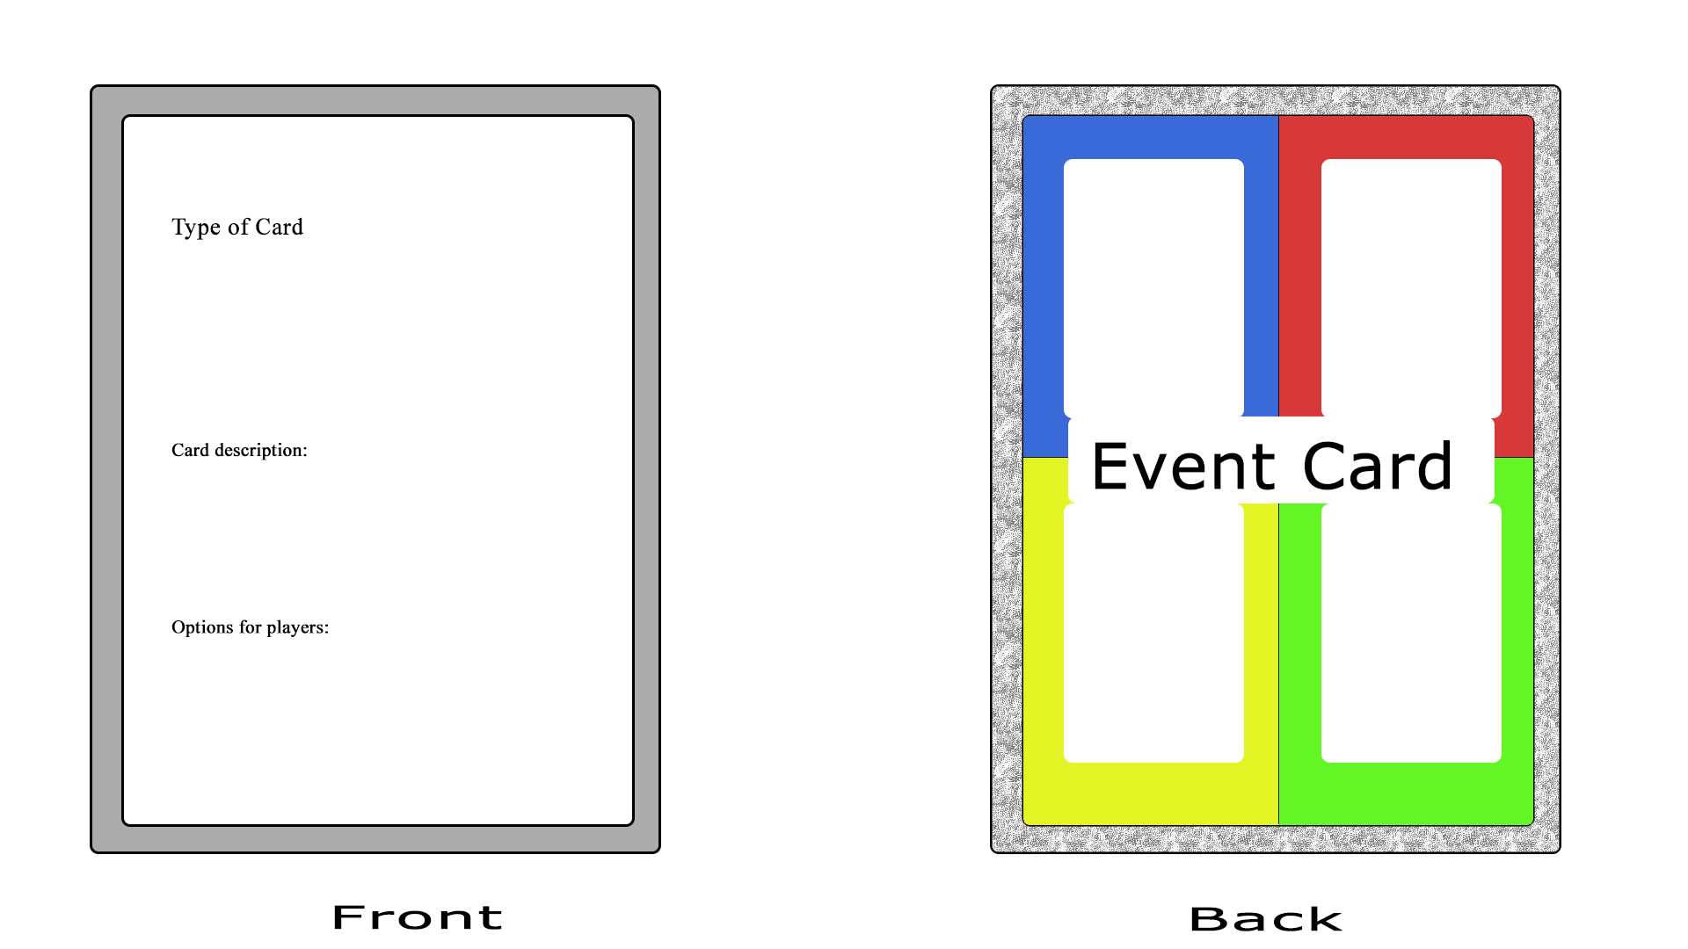
Concept layout for event cards.
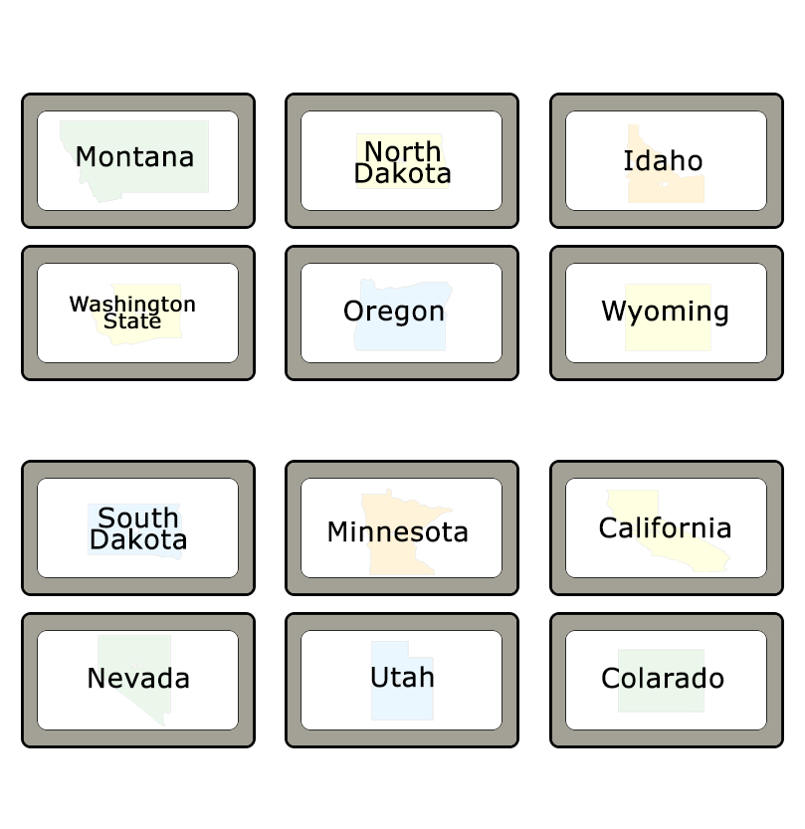
State cards when turned over features the state name and a water mark of the state.

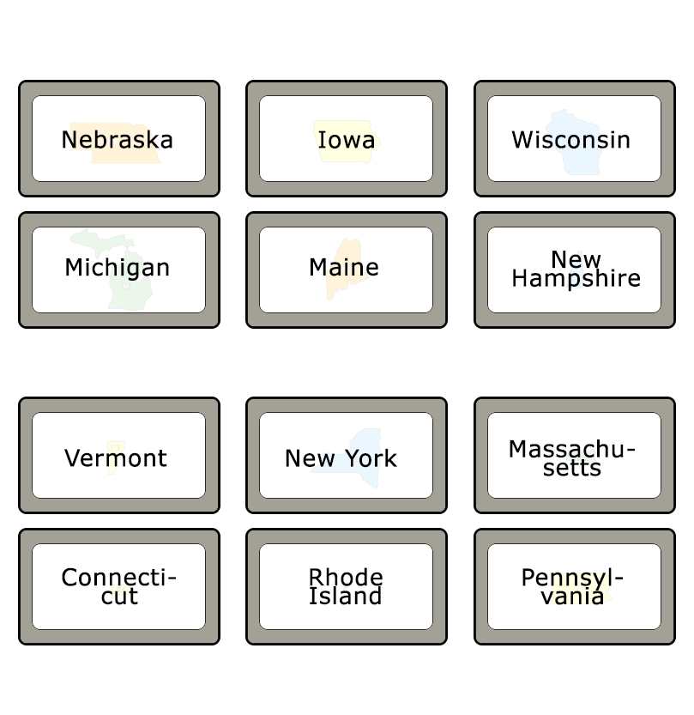
State cards when turned over features the state name and a water mark of the state.

State cards when turned over features the state name and a water mark of the state.
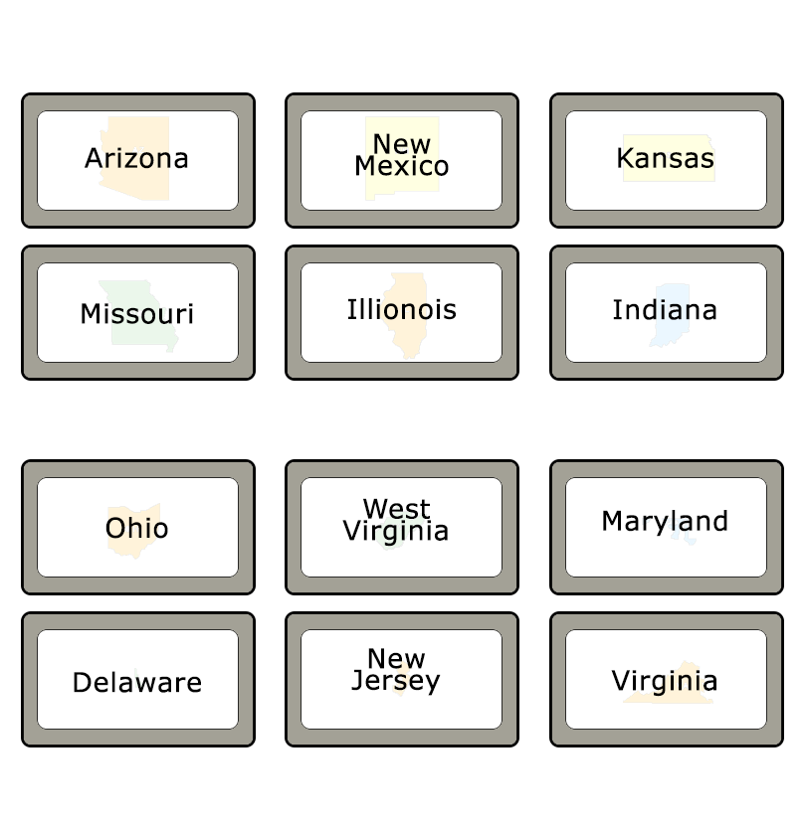

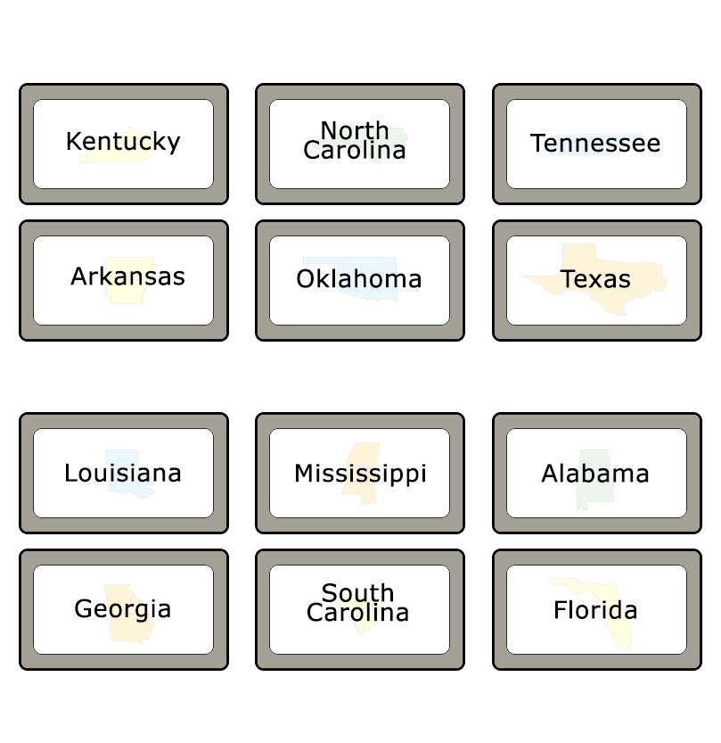
State cards when turned over features the state name and a water mark of the state.

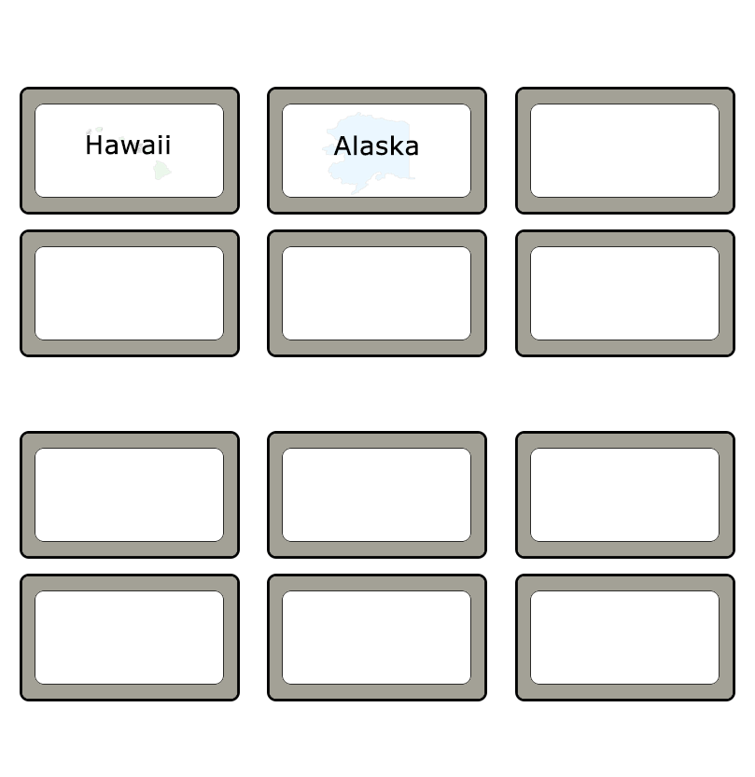
State cards when turned over features the state name and a water mark of the state.

Game board concept, every black dot is a peg hole, the smaller states in the northeast have a separate square attached to it to better accommodate the pegs.
