Jeremy Lanham
Academic Design Document
7/21/14

“Finding X”
An Academic video game

Academic Content - Introduction
The Academic content of an academic game can completely change, hinder or help the designer at work. In this project the academic focus is math or arithmetic for being systematic and logical. To be more specific the content is exclusively algebra for being a elementary and beginning for advance math where a game might hinder a students learning. Being focused on math for this project not only helps streamline the work and thoughts of the designer but give head way to many more ideas and future prospects.
Academic Content
The Academic topic to use in creating my game, not only had to be something that I myself was knowledgeable about but also quite fond of, with this in mind I chose algebra. My thoughts had drifted to focusing on Geometry and Critical Thinking topics. The problem I had found with this is that this might not turn out to be an actual game for learning and in the end instead the educational aspects would be a forethought. Although this also might be my saving grace in terms of completing my project. The current idea is to create a game that utilizes geometric shapes and rules to allow players the ability to slice up a 3d model in a unique way so that when unraveled would connect multiple points.
In a more general outlook and because it is always good practice to have a back up plan, but I was thinking of using math in general. Math as an overall subject is fairly easy to understand and is quite easy to come up with ideas for. The main problem would be creating a game that was not an empty educational game, where players are just doing math rather then playing it. I feel this is a better place to start but I am sure that I will quickly fall back on to Geometry. Actually I had come back to the conclusion of algebra after coming up with an idea that peaked my interest, using algebra as the topic and combining it with eye spy, where the player has to literally find, X.
Since I did not properly cover this in the beginning one allow me to better explain the discipline, subject and content I have in mind for my project. First of all I am very big supporter of critical thinking and problem solving so to make this brief, the discipline I have chosen is math, the subject algebra and the content is to be single variable equations or finding X. For my self this topic has to reflect the amount of time I have to actually work on the project along with what I feel like I am confident in teaching another individual. After all what good would a learning game do if you did not feel comfortable teaching another person the subject at hand let alone making a game for it. At the same time algebraic subjects and problems are always very systematic and that is what makes them easy to work with in this time frame.
I have spent some time going over different academic subjects in my head and comparing them against not only the time frame I have to work but also the legitimacy of them. As I have read in one of the readings or the article titled, Instructional Games: A Framework, by Valiathan and Annand, an instructional games can completely not relate back to their subject matter. I believe I typed out my thoughts wrong in that last sentence, essentially what I want to say is I want to focus on delivering a message and having my players learn rather then having them memorize information to succeed. With this in mind algebra is a pretty solid way to go because it is systematic, rigid and one can not get away with merely guessing on it. Now that article did help me solidify how I want to focus my game and gave it to me in a way I really understand it. Basically this is what I pulled from the article, the instructional game can focuses on three different aspects, Strategy the way the player plays the game, Score the way the player is awarded for succeeding, and Message essentially what the player is learning. To me I wanted to focus on the strategy and message of my game, rather then put to much of an emphasis on score. Although score will play a role in my game, having the player grasp the strategy and message will give them their real score.
Instructional Design – Introduction
Within this project multiple learning principles and ID theories were examined and focused on. Analysis, Design and Active, Critical Learning are the three learning principles focus on for their rigid and problem solving focus, feeling these were a perfect match to focus on for a game involving math. Equally the ID theories that were deicded to help reinforce the thinking of the project are Dewey's learning by doing theory, Bandura's observational learning theory, and Miller's Information processing theory. A designer such as myself I find it more important to stem your arguments and knowledge from the gaps left by your game design.
Instructional Design
Learning Principles, honestly I think of them as being as more like the parts to a model or you could say the pieces to help justify the design of your instructional game. The first principle I took to was analysis, or more simply put the clarification of the goal of the academic material. What this is to my game is telling the player that their ultimate goal of the game is to understand how to solve algebraic equations, except in a more abstract or indirect way. Secondly the Design principle, or the appreciation and acknowledgment of the design for the game to help further enable learning. When applied into my game the player will understand how moving through the three steps of, solving an equation, gaining a hint and Finding X, keep their minds focus and active then when they guess wrong, their eyes are already right next to the equation to gain another hint. Lastly Active, Critical Learning, or simply, the learning environment is set up to encourage active and critical thinking and not passive, learning. As to not repeat my self I spoke the three steps players run through in my game, at each step the player will have to use their minds actively and will not be presented with the information the game is trying to teach them.
Using the three principles, Analysis, Design, and Active, Critical Learning, and even related them back to my game, but not what happens when all three work together. Essentially my theory is this, after the player plays one level of my game they will not only understand the simple Design behind it but then also they will have been able to Analyzed the game to reinforce the design principle, and vice versa. With this the user will be Actively and Critically thinking rounding everything out. Now for the fun of it and I thought it looked cool, I have included a diagram of how I see these three principles working together. Additionally, another screen-shot of a mock up of one of my levels but with a really rough flow of how I see my three chosen principles working in the game. Speaking of which an article by a, Miller, Jessie L., and Miller, Jame Grier, titled,”Greater Than The Sum of its Parts III. Information Processing Subsystems,” brought up a good bit of evidence pertaining to my diagram below. Simply put the articles talks about how living systems across evolution continually to absorb information and change accordingly, but some systems lack structure and process. These systems instead substitute with current systems in unique ways. Now when put into the context of the diagram below, it would mean that players who are still trying to figure them selves out might not have a set process or structure and so they will have to actively learn how can they use their other skills to learn and complete the game.
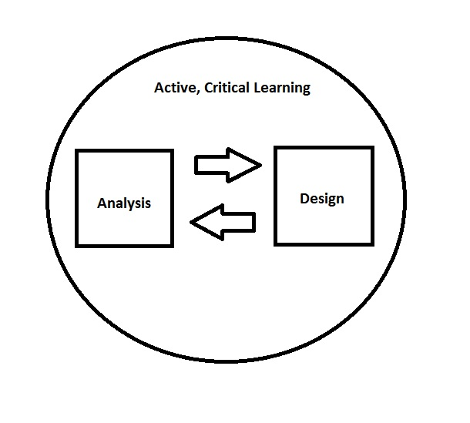
Analysis, Design and Active, Critical Learning, are the three ID principles I have decided to focus on with my project. Now the fun part comes to having to further refine my argument for them. If I would have to start this reinforcement I would have to start by bringing up one of Prensky's first points about Gee's book in that Prensky sees Gee's book as very personal or first person to keep it simple. It's in this stance that I have to agree with Prensky about Gee's book however, I believe that is one of the fundamental reasons behind why video games are so effective at being teaching devices. So to have the experience and wisdom of another written down in that same style as it is most effective just does more to reinforce every about video games and learning. Staying on track however, I described my process in the last assignment, allowing the player to create their own process and ideas of the game by constantly running over it. Well if there is one thing that is to be said is that the idea of semiotic domains and identity are not just exclusive to an RPG. What I mean is my players should find the time and thinking they have infested into mastering this simple system should further reinforce the educational purpose of it, because simply put they would have put their own processes to work in the game.
That reminds my self you simply can not rely on one point to reinforce anything, so another one of Presenky's arguments that caught my attention was, the analysis of the terms Gee used in his book. To me this seems quite frivolous because like I said in the previous paragraph, Gee's book is written just like how video games happen to teach others. Essentially Prensky brings up that Gee does not use no Jargon when it comes to video games pertaining to education, (if I read correctly). Now to push Presnky's argument out of the way Gee is merely practicing what he preaches here, in the way of situated meaning and learning. In other words Gee understands the terms he would normally apply to any thing from his career is not the same in the idea of video games, and as a result he refrains from using it.
So the three ID theories I want to say that not only caught my eye but also work well with supporting my game design are, Dewey's learning by doing theory, Bandura's observational learning theory, and Miller's Information processing theory. Yet why are they similar, well lets imagine it this way, what theories do not have to do with my game? Well for starters any theory that involves behavior for one, much akin to Erikson, or Locke's theories can not really achieve fruition in my design. Thus I look for logical or more so theories that can help support a game design and principles that reflect how small my game actually is. After all my design is focused on the player moving from one section of my screen to the next, evaluating themselves in order to learn and adjust. With this is mind I certain ideas come to my mind. First off repetition, one of the do all any all methods of learning, covered by Dewey's Learning by doing theory, where learning occurs through experience. Secondly Observation covered by Bandura's Observational learning theory that behavior can be learned through observation of others, essentially I want to flip this theory on it's side and instead have the player view themselves playing my game to further learn, and lastly Miller's Information Processing theory which pertains to the human mind being able to hold 5-9 chunks of information at a time. Some further backup evidence for me choosing Bandura's theory is, by an article by Prichard, Stephanie titled,”Practice Makes Perfect?: Effective Practice Instruction in Large Ensembles,” what I mainly want to touch on is that this article focuses on music practice. Well the relation to me is that practicing music the performer is constantly hearing themselves and providing themselves with auditory feedback and the article talks about how teachers model correct or preferred performances/actions, in the end this proved to be very effective at increasing the musicians skills, and much to the same as my game the player can watch themselves and improve their math skills. The game that means it's a restriction for my self, it means that I need to as a designer regulate the amount of information I am providing the hints in my game should not be to convoluted lest they take away the true subject of my game.
Designing Games for Learning: Insights from Conversation with Designers, pretty interesting article, although in general I do and I am sure a lot of other students to sort of already know about the information presented by Isbister. Although I will once again admit I do not have exact words for this type of information provided, I mean the ideas of Fun, Polish, and engagement just to name a few are all things we as gamers or game designers have come to know and recognize. Now this does not make us exactly authorities on the matter, but as said in the article game designers really do not publish this kind of stuff for some form of official academic or professional writing. Although with that small thought and when you think why, it's because this career field a lot of people want to break into is not one exact science per say, heck the video game industry takes portions of psychology, journalism, computer science and business all of which have to be balanced to make something great come alive, in other words it is a battle ground and unless you really like some one, you do reveal the secrets which are your ways of making a good video game (How you view fun and polish etc.) to some one else. Essentially what I learned, is you have to make your own morales, values and even goals for your game design as a game designer.
Game Design – Introduction
Game design is a fickle matter, interpret an action one way and you improve your game, while the other way may harm it, ultimately it comes down to what you perceive to be good and bad. Three things mainly went into the ideas of the game design, creativity, simplicity and accessibility. The name of the game is “Finding X” where players have to solve algebraic equations to unlock hints to, Find X, a tiny little fellow in the shape of an X. With the premise of creativity, simplicity and accessibility in mind, the game reinforces it's academic content while becoming a helpful resource for students.
Game Design
Thinking about Game Engines and the game style its self I would like to try and stick with a 3d game and so my Game Engine of choice is Unity. I have had some experience with Unity following my capstone class which utilized it pretty well. Although I am not an expert programmer, but if I can pound my head against a problem enough I can usually accomplish what I set out to do. Alternatively I have looked at the Cry Engine and Unreal, which I have less amounts of experience with but these two are arguably stronger then Unity. Either way in the end I want to focus on having a 3d game because that is where my strong suit is in terms of graphics and presentation.
As a back up further thought was to use mysql, html and php, which seems like a weird platform for a game but these languages are fairly easy and have been used to make games before. Alternatively using javascript in place of php would be better for flexibility and production, in the end however it would mean giving up my 3d game. I have been known to be a bit to ambitious and dial back my ideas in the end so this is most likely going to become the outcome of the my semester. Yet I have also been known to play devils advocate and finish the work I set out to do.
The content in my game will cover single variable equations, or as I like to put it, Finding X. This is because the current Idea of my project is aptly named, Finding X, where the player has to choose from number of hiding places to Find X. The way they do so is by inputting the various steps of a single variable equation. Every successful step provides a hint to which hiding place X is. Now I know what you are thinking, why am I talking about so much of the game and not the content, well it is because I am trying to merge the two together. For instance taking the systematic nature of math and algebra then allowing the player to chose when to guess where X is, seems a little convoluted. Yet from my experience, and I am not saying every one is the same, but certain equations can be solved with a less amount of work. These people who can usually do the problem in their head are also the people who will most likely find X with very little clues.
As for the actual design of the game, I have still not settle on how I should make it, although some early mock ups below is essentially the direction I want to go in. Essentially from the mock up below, the game would be arranged into three windows, One containing the colorful squares, cubes or shapes that hide the letter X. In a second window the Find X window I will call it, contains the actual equation and player input fields, here they player will input the next steps of the equation, so in the box with the number one next to it, the player would if knowing the answer input, x=13-3, which would then change the third window. The third window, or the hints window, will display hints depending on if the correct step has been inputted. So continuing from the last sentence, when the player inputs, x=13-3, then the first hint will reveal it's self. I am certain this is the direction I would like to go in terms of the game and will make for a fairly easy yet deep project. This is only an example of a first level, obviously getting longer or more complex equations will increase the number of lines and hints along with hiding places for X, but basically when the player feels they know where X is they can just click on a square to guess, but they have only two chances if they miss both they have to solve the equation fully to progress to the next level.
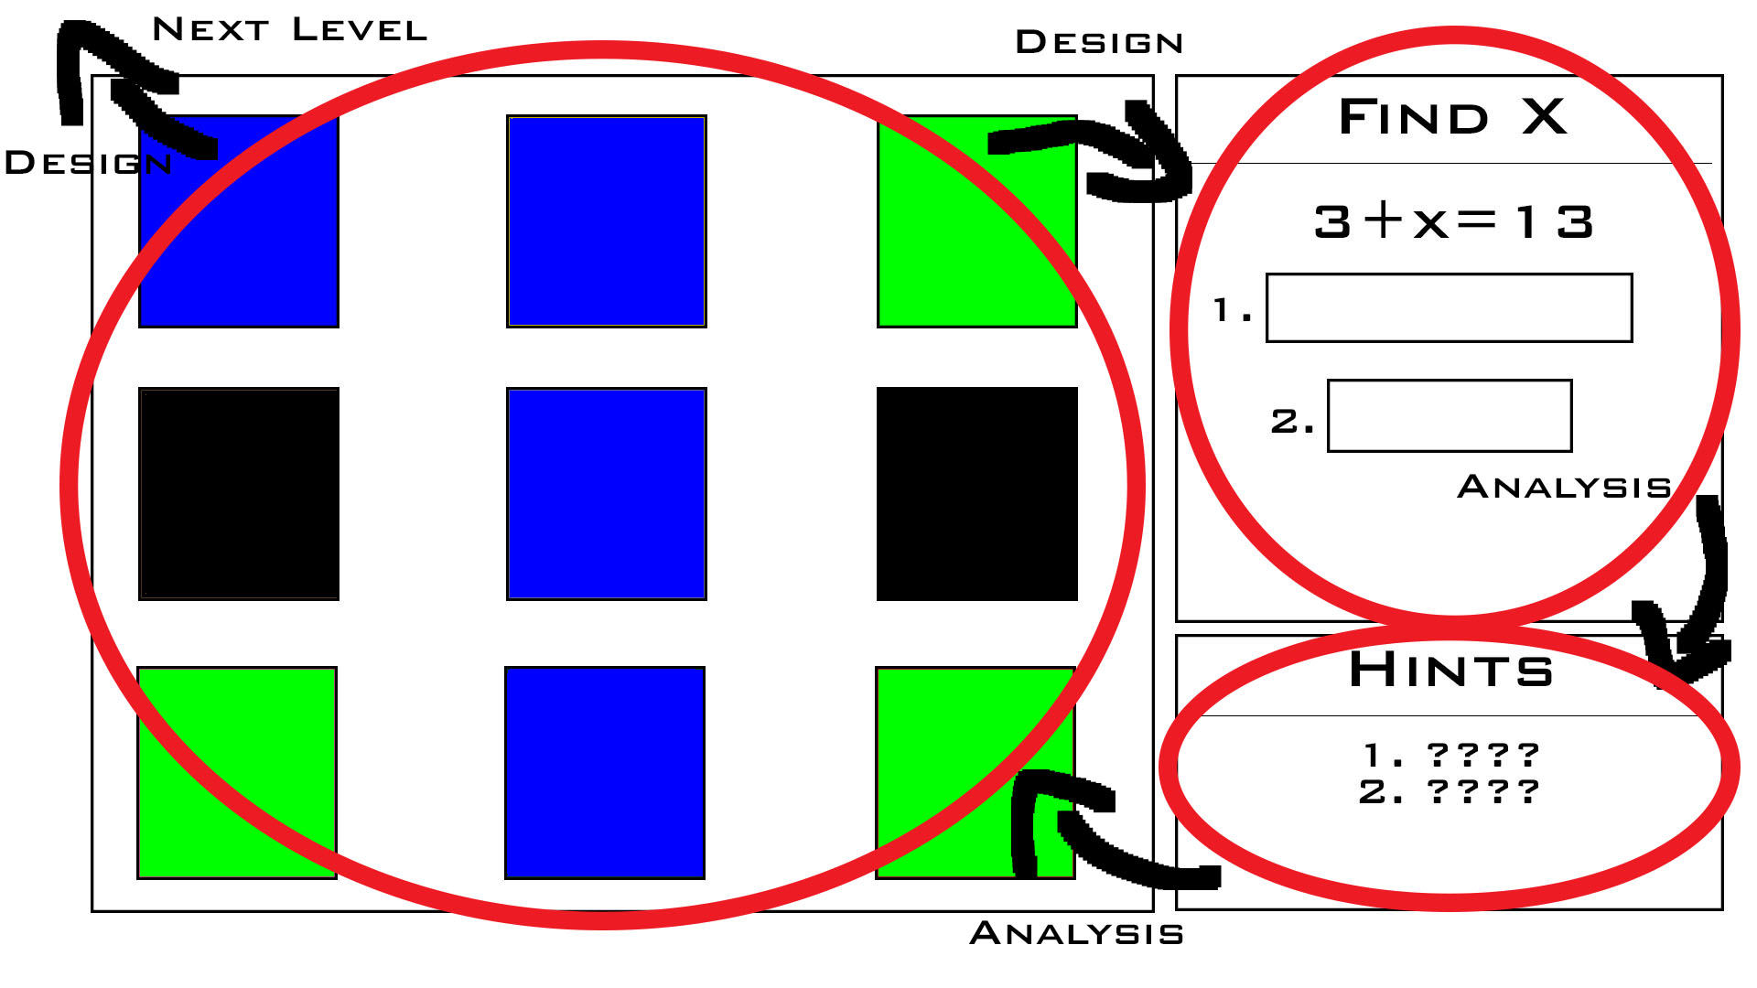
Here is a quick rundown of the screen shot above, First of all players start in the upper right hand corner to examine and begin to solve the problem, from here they move down to the hints section to find what kind of hint they have, here is a first section of Analysis happening, for the player is trying to decern where not only X is but also if they need more hints and should complete the problem more. From here they move to the actual graphic or finding space to find X, and the second part of Analysis happening. Basically they Analyze the finding space to try and figure out where X is and compare their ideas against the hints. Now depending on whether or not they find X the design principle will come into play, for if they do not find X they will be right back to solving the equation with the understanding of the design behind not only the game but the current level. IE finding a pattern within the hints and which steps would yield the best ones. Though if they do find X then they leave to the Next level understanding the design of the game. All this is encompassed in the principle of active critical thinking to help them learn the academic material.
I have not really came up with additional levels, per say for my game, because my games levels are really formulated to be fast easy creations, I have however decided on a few ideas to finalize the games levels in the coming week. First of all is the rule that the player will not be able to find X until they have completed at least one line of the equation, the X they have to find graphically will not even exist till they have met this condition. This is to stop the player from getting a lucky guess. Secondly levels will follow a common structure of having three hiding places per line. I always have to design some form of structure for my games to help work load, and following this rule will ensure that my levels are not only consistent but balanced. So my previous mock ups do not really reflect this but you can imagine in a two step equation, you would just cut off the bottom row of boxes.
So unfortunately I do not have many other screen shots to give out, but some things I have needed to think more of in depth are the actual hints I will supply my player with as a reward for completing a step in a equation. At first I believed making hints pretty cryptic where each line was like part of a haiku. In this sense the player would have to be pretty crafty before they figured out where X was with out completing the problem at hand. This lead me to an idea of using a more linear style approach, that each hint would lead the player to X's specific location. With this however I remove a design aspect of my game of allowing a player to choose to find X at any time they wish. So finally what I have decided on is to make hints that do two things, Remove possibilities and Add and Remove possibilities. With this the player can discern after completing a few steps of the equation where X is if examined closely but also when completing the equation there is still a little more thinking to happen in order to fully figure out where X is.

Example (three step equation):
- Near the corner of Red box and Green box.
- To the right of Yellow box
- Below the Blue box.

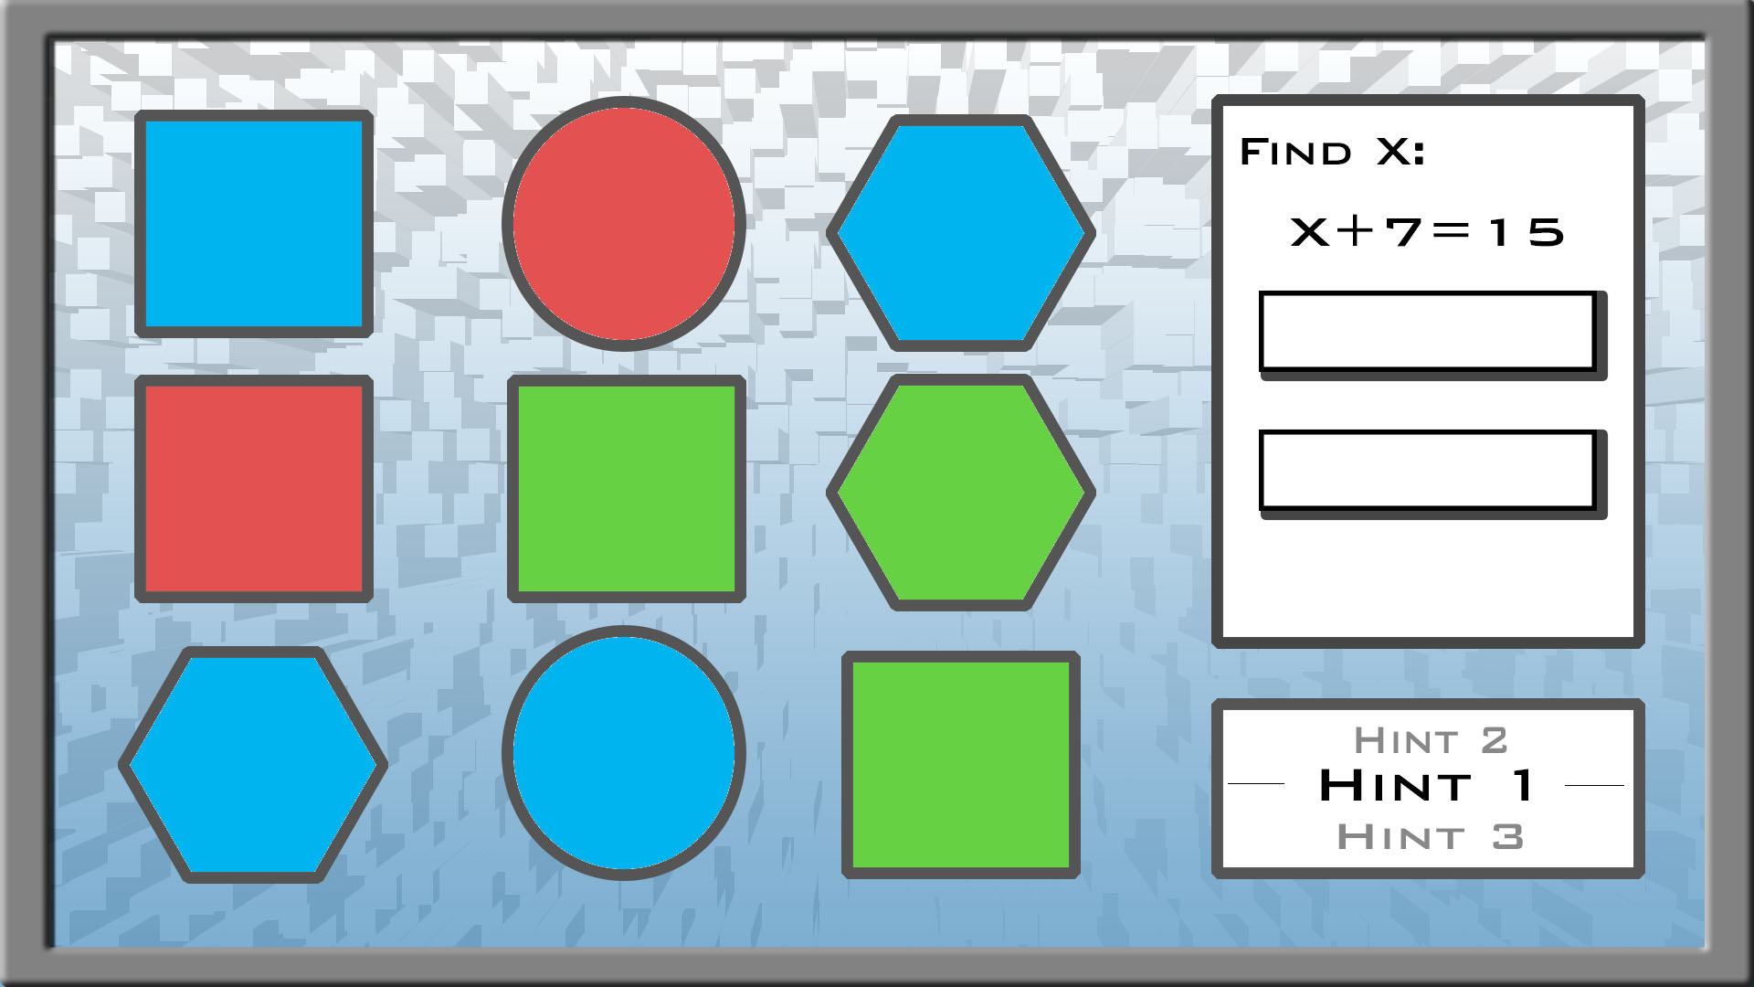
Additionally I am further examining the possibility of using a different engine for my game as well. I may be willing to learn and am currently taking COSC 250 at the moment which is helping me acquire skills in Unity, but the problem is I may not have time to fully complete the project in Unity. Instead I have opted of using a language I know that is easy, HTML, mysql, PHP, java-script, these four languages a know quite well enough that I should be able to put together my game in. Alas I am not sure, but Unity is very alluring because of the fun animation effects I could make happen which is a big plus to me because I contain a lot of 3d animation and modeling knowledge. Alas this part is still being debated with my self if you happen to have any insight please feel free to say so. So here is how I want to really get the UI in the end, although I will admit I did not completely think this one out. Obviously the shapes are not 3d at the moment and that kinda hurts the preview here, but that will come within time of the final project. Essentially I want to turn the hint field into a rotating scroll box that the player can sift through the hints, not only is for my own liking but I feel that if the player in this situation the player can focus on one hint at a time to better understand them. Instead of taking in a load of information at the same time, and yes this will need some tweaking for the final project to make things fit. Secondly if you have not noticed I have made some additional shapes, what I have decided is to work in different shapes to make better challenges. So If I told you one hint is to check the blue corner, wouldn't you be confused? But then the next hint says the behind the green of the same blue shape. In this situation the correct answer is the green hexagon. The last thing I want to cover is the 3d back ground, the current back ground is still place holder, and the idea is to have something of a boxed room with shifting colors as to add a little bit of elegance and not take away to much attention from the player.
Conclusion
The project,”Finding X,” is the focus on using systematic and problem solving centric theories, game design and principles to help students learn algebra in an enjoyable manner. Through the use of modernistic and solid visuals and active learning game design players will find themselves learning algebra very quickly. Further more players will walk away with a new found practice for problem solving and independence they have built themselves while beating the games levels.
Works Cited
- Schmidt M. Learning From Teaching Experience: Dewey’s Theory and Preservice Teachers’ Learning. Journal Of Research In Music Education [serial online]. July 2010;58(2):131-146. Available from: Academic Search Premier, Ipswich, MA. Accessed July 20, 2014.

- Schank R. Revolutionizing the Traditional Classroom Course. Communications Of The ACM [serial online]. December 2001;44(12):21-24. Available from: Business Source Premier, Ipswich, MA. Accessed July 20, 2014.

- Prichard S. Practice Makes Perfect?: Effective Practice Instruction in Large Ensembles. Music Educators Journal [serial online]. December 2012;99(2):57. Available from: MasterFILE Premier, Ipswich, MA. Accessed July 20, 2014.

- Miller J, Miller J. Greater than the sum of its parts III. Information processing subsystems. Behavioral Science [serial online]. July 1995;40(3):171. Available from: Business Source Premier, Ipswich, MA. Accessed July 20, 2014.

- Rogers PR, Miller A, Judge WQ. Using information-processing theory to understand planning/performance relationships in the context of strategy. Strategic Manage J. 1999;20(6):567. http://search.proquest.com.proxy-ub.researchport.umd.edu/docview/225005129?accountid=28969.

- Gee, James. "Introduction." What Video Games Have to Teach Us About Learning and Literacy . New York: Palgrave Macmillan, 2007. . Print.
Prensky, Marc. Fun, Play and Games: What Makes Games Engaging . : , 2001.

- Prensky, M. Escape from Planet Jar-Gon Or, What Video Games Have to Teach Academics About Teaching And Writing . A Review of What Video Games Have To Teach Us About Learning and Literacy by James Paul Gee, 11, 15.

