

Authors:
Andre Doucet
Brian Dieffenderfer
Ernest Roberts
Jeff Evans
Jeremy Lanham
Robert Myers

For: Xbox 720 (or whatever next xbox is called)
Rated: T for Teen

Summary: WorkOut: Kung Fu is an exercise game to be used in conjunction with the xbox 720, Kinect and Illumi Room that has players performing various martial arts style’s and training in their living room to help learn self defense and lose weight. The game features several different challenges and training exercise to warm the player up or really test their limits. The staple feature of the game however is the,”Way of the Warrior”, game mode that gives players a set number of levels to play through to really test the player and make them sweat. The game is meant to not only help players lose weight but help them work and learn the basics of martial arts techniques and offer a more interesting experience. When players first start up the game they are given a choice of martial arts style, this style provides a basis for the game to train the player but also give them the chance to score bonus points when they stick to what they know and perform the various techniques of that style against enemies. After selecting their martial arts style they are greeted by their trainer/sensei that is unique to the style they chosen and are ready to begin. The way the game works is players are given a choice to train or challenge themselves. The staple of the game is the way of the warrior game mode where the player is thrown in the middle of wave after wave of enemies that aim to knock the player out. Some enemies will have a speciality or two about them along with different amounts of required strikes to beat, so the player must be aware of the most effective method to progress is. Players are also encouraged to combo moves so instead of just punching an enemy why not dodge his attack, then his friends attack then attack back. Now depending on difficulty players are given a number of strikes if they receive the set number of strikes then an extra one they lose. Players can play with another player in various co-op and versus challenges since working out with a friend is always better. The game keeps track of the players progress and can even show how much the player as grown from the game. As players keep playing the game they work to have a higher place on the leaderboard in various categories to help measure them against other players.

Target Audience: 13+

Estimated average session: 30 mins to an hour.

Game Mechanics: Players perform basic attacks, dodges, blocks and counters read by the Kinect to progress through different stages and play sessions. Players can turn on the Illumi Room mode for a more robust and interesting experience. Players can play with one other player in various challenges.

Game Dynamics: Enemies engage the player from either left or right at different times and difficulties. Players may be forced to hold out against up to three enemies at a time. During the Illumi Room mode, enemies engage from all sides at different intervals depending on difficulty this may include more or less enemies per stage. The game may also interrupt a player’s session to do one of various lighting rounds, that have the player doing a specific action very quickly and often.

Game Aesthetics: The game is very stylized focusing on the anatomy of the xbox avatar and vibrant colors on the TV but when the Illumi Room mode is active the projection around the room has a traditional asian theme with a black and white color scheme. Players are represented in game by their xbox avatar but with a set of clothes that match the style of martial arts they are using.

Menus: Menus and submenus

- Main Menu:
  - Single Player
  - Multiplayer
  - Options

- Single player
  - Way of the Warrior
  - Training,
  - Challenge
  - Stats and Leaderboards

- Multiplayer
  - CO-OP Challenge
  - Versus.

- Options
  - Video
  - Audio
  - Calibration - Kincest
  - Illumi Room - Auto or off, Auto is on if the game mode allows it.
  - Calibration - Illumi Room
  - Profile - Swap the main avatar and martial arts choice.
  - Aesthetic theme - Change between different eastern or western art styles to suit you.

Trainer/Sensei:

- Every player will be taught moves and techniques by their sensei. The word “sensei” is a Japanese word meaning “teacher” or “master”. Depending on the martial arts style chosen by the player, the sensei for them will change. These teachers will compliment the player when they do moves correctly and provide tips and advice on how to master techniques.
- Some teachers include:
  - Jackie Chan
  - Bruce Lee
  - Jet Li
  - Po (Kung Fu Panda)
  - Mr. Miyagi (Karate Kid)
  - Others yet to be named.

Way of the Warrior: Fully compatible with Illumi Room.

- The main single player mode for players and makes full use of the kinect and illumi Room.
- When illumi Room is active players are attacked from every direction and depending on which wall they are looking at they will face the enemies on that wall.
- Players choose a stage and difficulty then proceed through seven levels that get progressively hard.
- When players choose a difficulty they will get different amounts of heads up displays and amounts of enemies. Also based on their selection they will get a different amount of chances to stay in the game.
  - Easy: Players receive a heads up display for every major event and attack. They also face off against the lowest number of enemies in the game. Players are given five strikes here before they lose.
  - Medium: Players receive a heads up display for when enemies are approaching on different walls but none for when to block or dodge an attack. They also face off against a moderate number of enemies. Players are given three strikes at this level before they lose.
  - Hard: Only for the most advanced players, the player faces off against a huge amount of foes and receives no help from the game. They can only make one mistake until they lose the game so caution is suggested.
- Strikes work as followed, for instance on medium the player can take three hits but does not lose until they take the fourth.
- As players playthrough Way of the Warrior they may have to defend and fight up to three different enemies at once and truly display their skills as a martial arts master.
- At the end of the stage players are given an overall performance rating and can view a more detail page by selecting the stats section.

Challenges and Lighting Challenges: All challenges are co-op enabled as long as they are started through the challenge select menu. They are also Illumi Room compatible in single player mode and are affected in different ways.

- Lighting Challenges: These challenges in particular can pop up during a players game session.

  - Shuriken Shuffle: Dodge the incoming shuriken and take care not to get hit, for every shuriken you dodge you gain extra points but as soon as you get hit the games done. During Illumi Room play the player can see the dodge shuriken fly across the walls and get stuck in various objects.

  - Falling petals: Be amazed at the pink petals that fall around you and grab as many as you can, for every petal you grab graciously and smoothly you gain extra points. During Illumi Room play the petals will spread from not just the tv or main display but also around the entire room making the player have to look from all sides to get the petals.

  - Show off: Check out the next technique or action in the list and show off your skills to the crowd, but beware mess up once and you lose those extra points. During Illumi Room players get to see a bigger crowd and a more interesting setting then before.

  - The Balancing act: Players are dropped onto a bamboo pole that they must balance on until time is up, if they fall then they lose any extra points. During Illumi Room players will be greeted by their friends avatars balancing on poles so show they are not alone and create a more interesting experience.

- Selectable Challenges: All lighting challenges are available in selection as well. Only some challenges have Illumi Room support as long as they are single player.

  - Endurance Challenge: Use all that you know and see how long you can last against wave after wave of enemies. This mode is just like way of the warrior but is an endless challenge.

  - Block All: Just as the title says you are only allowed to block all incoming attacks.

  - Dodge All: Just as the title says you can only dodge the attacks being thrown at you.

  - Attack All: Time your strikes right and don’t falter as you stay on the attack.

  - Ninja Style: Two players face off in a classic game of horse, but instead of building the word horse we have the word Ninja.

  - Time master: Players face a strict time limit to get past each obstacle in their way, players face challenges based on the stage that is selected at the start. During Illumi Room players can see their next challenge out in the distance to better prepare themselves for what lies next.

  - Shadow Box: Players can go head to head trying to get legit strikes on the other player and win.

Training: All training is single player only, when Illumi Room is turned on it merely provides an interesting setting for the player to train in.

- Basic Workout: Work on your body overall with a combination of endurance, strength and agility workouts.

- Balance: Work on your balance while trying to keep a bucket of water from spilling or if you prefer balance on one foot and maintain your level.

- Technique workout: Work on your technique to prepare yourself for harder challenges facing off against a variety of dummies and enemies.

- Meditation: Take a calm minute and just enjoy the visuals and ambience of the game while you put your mind at peace.

- Tai Chi: Relax your mind and body while performing slow, smooth flowing techniques. When Illumi Room is turned on, the player is surrounded by silhouettes of other avatars doing Tai Chi.

- Endurance Run: Enjoy the scenery as you run in place and work on your lung capacity.

HUD:

- During challenges and modes players will get a strike counter in the upper right hand of the screen to show how many strikes they have left till they are knocked out.
- On Easy Difficulty players will receive signals of where they need to either block or dodge at specific locations. These come in the form of a shield for block, star for hit or circle for block.
- On the easiest and medium difficulty players also receive a warning of where enemies are coming from next to prepare themselves. these come in the form of blinking arrows that point towards the general direction of the enemy.
- The score counter for the game will be right above the strike counter.
- When it comes to timed challenges the time will be displayed in the upper left.

Enemies:
- Black Belts - These are beginner level enemies that use bare handed attacks

- Kickboxers - Beginner to intermediate level enemies that use kicks as their primary form of attack..

- Ninjas - These intermediate level enemies use katanas and shurikens. They will also block attacks to prolong their life.
- Shadow ninjas - Higher level enemies that do more damage to the player. They have the ability to trick players into attacking their shadows.

- Grand Master - The Grand Master is the final boss that the player must defeat. He will have all abilities the previous enemies has as well as his own unique skills.

Martial arts styles:.
- Tae Kwon Do: A fighting style from Korea that focuses on kicking and using power from the legs. Punches are also used, but are not as heavily focused on.
- Muay Thai: Attacks consist of punching, knee strikes, elbow strikes, shins and feet.
- Karate: A mixture of all forms of martial arts.
- Wushu: This form of martial art focuses of smooth and precise motions.

Leaderboards/Stats: Examples of stats recorded through a players progress and on the leaderboards.
- Perfect score on a particular challenge (no hits taken, no enemies missed)
- Time High Score
- Personal Best Time
- Number of enemies fought off in a particular amount of time
- General Accuracy (obvious movement that hits/doesn’t hit an enemy)
- Precision (bonus points for hitting areas that disable enemy but won’t permanently harm them)
- Agility (enemy attacks dodged)
- Attacks Blocked
- Times meditated
- Times doing basic workouts

Achievements:
- Show On, Show Off - Complete Show Off challenge 100 times
- You Should See the Other Guy - Complete Endurance challenge
- Petal to the Medal - Complete Falling Petals challenge 100 times
- Shuffle and Deal - Complete Shuriken Shuffle challenge 100 times
- Jumping at Shadows - Win the Shadow Box challenge 50 times
- It’s About Time - Complete Time Master challenge 100 times
- It’s All In the Wrist - Complete Technique workout 100 times
- Going Nowhere Fast - Complete Endurance workout 100 times
- Middle Ground - Complete Balance workout 100 times
- Protection Perfection - Block 50 enemy attacks in one round
- Zen Master - Meditate 100 times
- Mastering the Basics - Complete Basic workout 100 times
- Cautiously Offensive - Hit special areas of enemies 50 times in one round
- Perpetual Motion - Dodge 50 enemy attacks in one round
- WATAAH!!! - Kick 100 enemies
- Fast as Lighting - Dodge and Punch 100 enemies
- COMBO BREAKER - Counter 50 enemy attacks
- Light as a feather - Balance on Bamboo stick without fail 30 times
- The Ultimate Warrior - Complete all challenges with perfect scores

Scoring:
- Hitting an enemy - 100 points
- Hitting an enemy in the head or chest - 200 points
- Successful block - 100 points
- Successful dodge - 150 points
- Successful counter - 200 points
- Combos -
  - 10-20 hit (x1.5 points)
  - 21-30 hit (x2 points)
  - 31-40 hit (x2.5 points)
  - 41-50 hit (x3 points)
  - 51+ hit (x3.5 points)
- Total Accuracy of attacks (calculated after each round) -
  - 95%-100% (x2 points)
  - 80%-94% (x1.6 points)
  - 65%-79% (x1.4 points)
  - 51%-64% (x1.2 points)
  - <50% (No extra points)
- Performing successful move within your martial arts style multiplies the points of that move by times two after accuracy and combos have been calculated.

Stages:
- Dojo: The place where all potential martial arts masters begin their training. This indoor training facility is where martial artists can go to learn, practice, and hone their skills.
- Forest: This stage is in the middle of the woods in a semi-open environment. It is bright enough to see the surroundings, but dark enough for enemies to hide and plan their attacks.
- Garden: A place for peace and relaxation. The beauty of the trees and flowers along with the sound of the babbling brook make training here that much more of a treat.
- Temple: An old temple where monks meditate and train in peace. They are not fond of outsiders and will attack if they feel necessary.
- Town: A bustling Japanese town full of vendors and citizens. One may never know who their enemies are in these crowds. Keep a sharp eye.
- Roadside: Never know what you may come across while traveling between towns on foot. Watch out for an ambush.

Audio: Just a quick run down

- The game features licensed soundtracks that pertain to martial arts from the past (ie Kung fu Fighting)

- The game also has original scores as to provide a sense of variety.

- Players can use their own music if they want to vai mp3 player or console.

- The game is also featuring ambient sound effects and noise traditional to the east but players can opt to change it to a more western approach.

How does this help with exercise:

This game will help the players exercise with its appealing gameplay paired with its kinect capability. No matter what difficulty is chosen, players will get a good workout from this game by punching, kicking, and dodging the numerous enemies that will be encountered. Along with the benefits of exercise, the game will teach its players forms of self defense that they can practice outside the game to both help them in the real world as well as improving their scores in the game.

Screenshots:

Main Menu
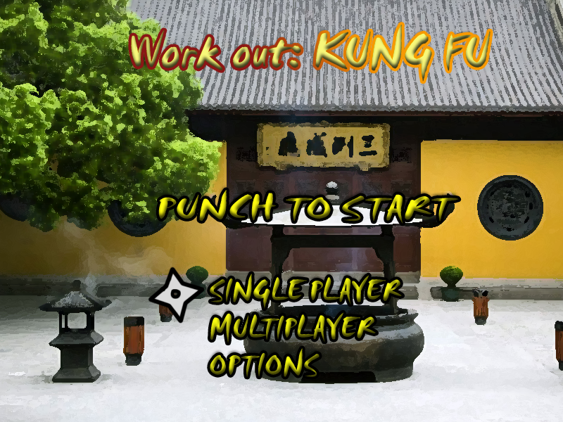

Endurance Mode/UI