Broton Pass Wars
Author: Jeremy Lanham

Quick Pitch: Broton Pass Wars is a free app that is one half twitter and one half war game, using a message system much like twitter users can send messages to each other in war like or fantasy style themes.

Summary: Broton Pass Wars is a new social game for android and IOS smart phones that allows users to send batons between one another in a war like fashion. In these Batons, users can insert interesting messages consisting of pictures, text and sound or a combination of the three. Users can customize these messages at any time but can only store up to two unless they pay extra money. In order to distribute a message the user selects a distribution method and then performs the necessary touch action. Depending on the method used the first person or set group number in the hypothetical line the user faces when sending out a baton will receive it and they will be able to read the message. When a user receives another users baton they will see who sent it and how it came to them, along with being able to read the message. The receiving user can choose to get revenge by sending the other user their baton if they wish. Along with basic functionality the app can keep track of various stats like who has sent the most batons and most used distribution method.

The Main Idea: Broton Pass Wars is aiming to be a new and innovative social experience that is sure to bring interesting situations. Since the app has not real rating out side of what content a baton may have within, practically any one can use this app, but with the implementation of a maturity filter within in the app can remove this obstacle. The main way of generating revenue is by selling additional baton slots and distribution methods for the app. For instance one of the additional ways users can distribute a baton is a carpet bombing. This carpet bombing distribution method will drop a set of a users baton across a wide area and every one who has the app in that area would get that users baton. This can be used greatly by ad agencies although a block feature would be implemented advertisers and other people looking to gain more exposure for themselves would be buying these different distribution methods constantly to maximize the use of the app. As said before users will be able to use this app on android and IOS, so when the app first launches it will be reliant on gaining users through the respective platforms front pages, but as the app becomes more widely used and word of mouth spreads the app will grow.

The Game:

Menus:
- Start Menu
  - Distribute – Users go here to choose a Baton and Distribution method
  - Customize – Users can customize their batons here.
  - The Supply Room – Players can manage their inventory and browse the case shop for additional baton slots and distribution methods, along with past messages.
  - Leader Boards – Users can view their own statistics as well as global and friend only leader boards.
  - Options – Users can adjust their privacy options, along with sound and other options.

UI:
- The game uses a set of menus for player navigation.
- When players distribute batons they will see the baton in the center of the screen along with a preview of the message inside.
- Distribution methods are located at the bottom on a sliding bar, players can tap on one of them to view it's details before deciding which one to use.
- Depending on distribution method selected users will either have to perform a particular slide action or select a area on a global map to activate the action. This is represented by either an arrow with a slide action or a map that pops open from the side.
- When a baton is received a message is displayed through the platforms message system, the baton drops on the users screen in the same position as if they were sending one out.
- When viewed the user can see the details of the baton at the top and bottom banners of the screen.

Game Play and Flow: *Please note users can not receive the same baton within a 24 hour period.
- When players first enter the app they will be greeted with a small overview/tutorial of how the app works and be told of the different privacy options available they so choose to use em.
- Players then will be asked to customize there first baton, they can choose to use any one or combination of text, pictures or sound.
- They will then be able to select what distribution method they would like and then shown what kind of action needs to be performed to complete it.
- Users will be notified if some one receives their baton, if the baton is received by multiple people then the user will be notified of how many people received it.
- Users who receive a baton will be able to view the message and choose weather or not to ignore the user based on the message content, retaliate or other wise be suggested the best method to send their baton to the user or to delete/save the baton for future viewing.

Distribution Methods: Users start out with three starting distribution methods that get put on a cool down after use. Other methods require a small payment for one time use or a bulk buy. Also to note distribution methods have different; cool down times and ranges. (Others to be added later on)

- The Bonk:
  - Description: A short range pass to give your friends a baton bashing. Chooses closest recipient that has the app enabled.
  - Range: 10 feet
  - Cool down: 1 min
  - Price: Free

- The Long Throw:
  - Description: Throw a baton long range in the direction you are currently facing first person in line will get your message.
  - Range: 50 feet
  - Cool down: 5 min
  - Price: Free

- Semi-Auto:
  - Description: Fire off multiple batons whenever you press the fire button. Up to 10 shots can occur.
  - Range: 25 feet
  - Cool down:
  - Price: Free

- Carpet Bombing:
  - Description: Send a huge wave of batons out from the skies in the direction that you are facing, any user in it's way will get your baton.
  - Range: Half a mile
  - Cool down: 1 min
  - Price: $1.00 per single, $4.00 per five pack

- The Blitzkrieg:
  - Description: Get your baton our there fast and easy, select 3 different locations on a map of your city and every user within those areas gets your baton.
  - Range: 750 feet for each area selection, Area selection is the users city.
  - Cool down: 1 min
  - Price: $1.00 per single, $4.00 per five pack

- The Sniper Shot:
  - Description: Guarantee a baton delivery in the direction you are facing, and once it is delivered your baton will continue through to the next three people in line.
  - Range: Infinite until 4 people have the baton.
  - Cool down: 1 min
  - Price: $.50 per single, $2.00 per five pack

- The Big One:
  - Description: Drop a massive load of batons on a massive area, every one caught in it will get your message.
  - Range: 5000 miles
  - Cool down: 24 hours.
  - Price: $5.00 per single, $20.00 per five pack

- Artillery Barrage:
  - Description: Unleash a constant barrage of batons on an area of your choosing around your city, for the next 12 hours any one who enters the area will get your baton.
  - Range: Half a mile for area selection, Area selection is the users city.
  - Cool down: 12 hours
  - Price: $2.50 per single, $10.00 per five pack

- Strike Drone:
  - Description: A very precise drone strike that also hits every one around your intended target.
  - Range: Any Where approved by the developer.
  - Cool down: 1 hour
  - Price: $1.50 per single, $6.00 per five pack

- Delivery strike team:
  - Description: Send out a small squad to hunt down 20 other users of the app and give them your baton.
  - Range: Infinite until 20 people have received the baton.
  - Cool down: 1 hour
  - Price: $1.50 per single, $6.00 per five pack

Earning system: The user can receive one random distribution method for free by how often they distribute batons. This starts out by telling the user that they have to use 5 more distribution methods to receive a free random one. The quantity of distribution methods ramps up by multiples of 2 every time a user gains another free method.

Other Cash Shop Packs: Along with users being able to purchase methods in bulk and singles, users can buy different packs and other add on content to make them stand out.
- Random Small Pack – A random assortment of 7 different distribution methods - $8.00
- Random Medium Pack – A random assortment of 16 different distribution methods - $16.00
- Random Large Pack – A random assortment of 35 different distribution methods - $32.00
- Appearance changes – Many of these have not been sorted but users will be able to purchase different stationary and appearance options for their batons. - $1.00-$5.00

Screens:

Example of what some what sees when selecting a distribution method while their message is displayed on screen.

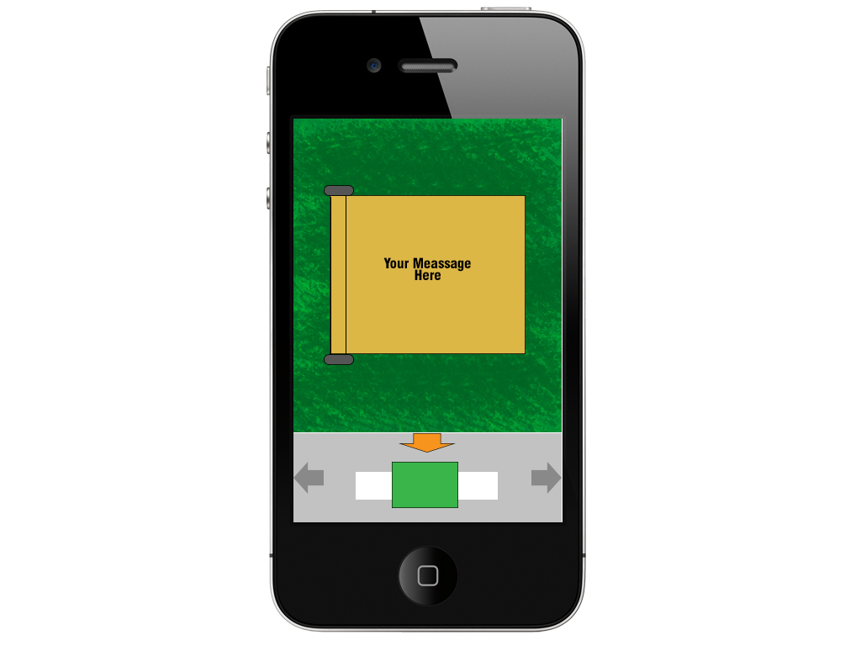
The bottom gray bar is the slide bar where the distribution methods are shown, and the baton with the message is in the center.

