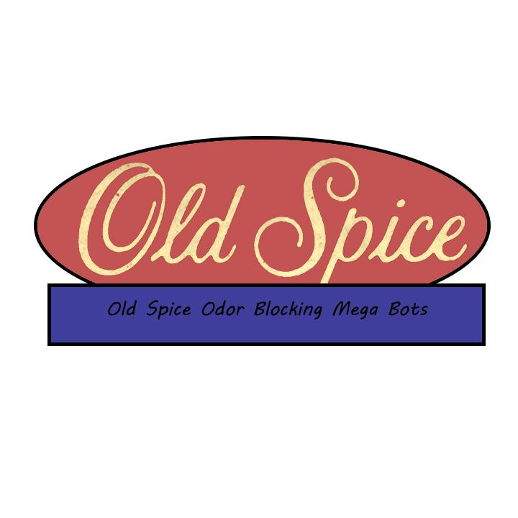

(OSOBMB)

(Inspiration taken from the Old Spice bottles)

Andre Doucet

Brian Dieffenderfer

Ernest Roberts

Jeff Evans

Jeremy Lanham

Robert Myers

**Summary:**

The game advertises Old Spice products by putting players in control of an odor-fighting robot sent out to get rid of stench monsters by shooting them with odor-destroying lasers. The games difficulty ramps up as new stench monsters are added giving the player more to dodge or more hits to change them into scent elves. Players are presented with a short scene of what the consumer is about to do for the evening and then they are ready for deployment. When the stench monsters are hit with these lasers, they become clean and masculine scent elves. These scent elves can then be picked up to help make the robot stronger and make a level easier to players. Players will progress through several different levels in an attempt to gain high scores and help the buyers of old spice products get prepared for their evening events. The game is built to play on the old spice website via flash and can even save players progress and high scores. Eventually the game will come to mobile platforms for a small one dollar fee.

**Target Audience:**

Primarily targeted towards males 8+

**Time to completion:**

Varies from user to user estimate is 10 mins a level.

**Narrative:**

You have been placed into a Old spice odor blocking mega bot, your mission, rid the evil stench monsters from the consumers arm pits and leave them ready for their evening events. You will be deployed on multiple missions so good luck to you mega bot the consumer is riding on you.

**Game Mechanics:**

The game involves players controlling an odor blocking mega bot from a top view much like the 1942 arcade game. As players fly through every level they will have to shoot stench monsters and convert them to masculine scent elves to gain points. When the stench monsters get converted to masculine scent elves can then be picked up for additional points and to fuel your masculine meter. When the masculine meter is filled the mega bot goes into a invincible state called hyper mode. The player then has 15 seconds of invincibility, 2 times score multiplier and rapid fire lasers. The player has multiple lives represented by old spice deodorant sticks, now the player is not allowed to be hit at all by a stench monster if they do they will lose a life. If all lives are gone and the player fails then they must restart. At the end of every level there is a boss stench monster that players will have to defeat in order to complete the level. After a level has been completed, players are given a rating based on their score and are able to check their standing on the leaderboard for a particular stage.

**Game Dynamics:**

As players progress through levels they will have to dodge incoming obstacles and destroy stench monsters that come from every direction.

**Game Aesthetics:**

Appearance will be similar to the design and color scheme of Old Spice products to subliminally remind players of Old Spice while they are playing. Music will have a loud battle quality and try to evoke a feeling of epic importance. Occasionally old spice icons like Terry crews will enter giving you words of encouragement and lighten up the mood.

**Game Menus and Flow:**

* Main Menu
  + Start
  + Leaderboards
  + Options
  + How to play
* Start - Sends the player to a level select screen.
* Options - Lets player change hotkeys, master volume and link to facebook.
* How to Play - Shows the player what everything on the HUD represents and tells them the controls of how to play the game.
* Level Select - Players scroll through available levels, any levels that are not accessible are greyed out. Once the player has chosen a level they are ready to play and are presented with the overview for that level then the actual game commences.

**Controls:**

* Movement - The player can move their robot with either the arrow keys or W,A,S,D.
* Shooting - Spacebar
  + May be held down for convenience, fires one projectile every second while held down.

**HUD:**

The player’s life is indicated by the number of Old Spice deodorant sticks in the upper left of the screen. The Masculine meter that the player needs to charge up by acquiring scent elves is located to the left of the player’s lives. The total number of points the player has earned is located at the top of the screen.

**Hyper Mode:**

When the player fills their Masculine meter they enter hyper mode. In this mode the player is invincible, gets more points and even shoots faster for 15 seconds. This mode automatically triggers when the masculine meter is filled up. Once hyper mode will start the screen will flash constantly and the players mega bot will begin to glow with old spice colors to further indicate what is going on.

**Levels:**

* Level 1 The Prom Night
  + Players have to help a nervous teen stay smelling great for their prom night, upon completing the stage the player is shown the success of the lad and upon failure it displays a splash screen of the teen depressed.
  + Players fight Stench blobs and bubbles on this level.
  + Boss of the level is Stench King the Stenchiest.
* Level 2 The Blind Date
  + Players have to help a rather nervous man be prepared for his blind date, upon completing the stage the player will see the man and his success with his blind date while if they fail the player will have the fortune of seeing the man left alone.
  + Players will fight a combination of Stench blobs, bubbles and flies.
  + Boss of the level is Lord of the Flies.
* Level 3 Peer Pressure
  + A teen is surrounded by his peer group and the only way for them to stand a chance at not becoming an outcast is the odor blocking mega bot. If the player is successful in the stage they will see the teen hanging out with their buddies but if the player fails they will see the teen all alone.
  + Players will fight a combination of Stench blobs, bubbles and odor goblins.
  + Boss of the level is De La Funk 0.
* Level 4 Exercise Excitement
  + A Man is trying to get in shape but does not want to stay smelly afterward it is the mega robots job to keep him smelling great. If players complete this stage they will see the man sociable and happy after his workout. If the player fails they will have to see the man alone and unwanted.
  + Players will fight a combination of Stench blobs, bubbles, odor goblins and odorpede’s.
  + Boss of the level is Agent Skunk.
* Level 5 Popping the Question
  + The big day has come for one man asking for his girlfriend's hand in marriage. If the player succeeds they will have the pleasure of seeing the man with his wife happy and carefree. Yet if the player fails the girl friend will be unreluctantly still say yes but they will be a bit disgusted and be reluctant to really hung her new husband.
  + Players will fight a combination of Stench blobs, bubbles, odor goblins, odorpede’s and Stench hulks.
  + Boss of the level is the Stench Deity.

**Enemies:** ( Note about damage: Every projectile the player fires is counted as 1 damage otherwise known as 1 hit and the player fires a projectile once every second while the space bar is held down.)

* Stench Blobs - Blobs of stench that try to cover the robots to short-circuit them.
  + 1 hits to destroy
* Stench Bubbles - When these bubbles are shot, they explode into smaller and smaller bubbles until the last few turn into scent elves.
  + 2 hits to destroy
* Stench Flies - Evil flies that shoot stench acid attempting to eat through the robot’s armor.
  + 2 hits to destroy
* Odor Goblin - These little creatures try to leap all over the screen attempting to make contact with the player’s robot in order to explode in a giant stench cloud.
  + 3 hits to destroy
* Odorpede - An odor-creating centipede-like enemy that can only be cleansed by taking out every link of it’s body.
  + 5 hits to destroy (1 for each link)
* Stench Hulk - A large and stinky enemy that attempts to grab the player’s robot with it’s long smelly arms.
  + 5 hits to destroy

**Bosses:**

* Stench King the Stenchiest - Giant blob of stench that shoots smaller blobs at you and demands that you go away.
  + Players must dodge or shoot oncoming blobs to avoid taking damage.
  + Takes 50 hits to defeat.
* Lord of the Flies - Hybrid man fly that sends his manure covered flies to attack you.
  + Players will have to destroy the flies the boss sends towards them very quickly to take down this boss.
  + 50 hits to defeat.
* De La Funk 0 - Former disco king and now washed up, couldn’t leave the past behind him. He uses his smelly hair sprays of musk he uses to keep up his hair up.
  + Players will have to swerve around small clouds of stench.
  + Takes 75 hits to defeat.
* Agent Skunk - It’s over when he turns around. He attacks using his tail. Once the animation is over he leaves a stench trail that covers the majority of the screen.
  + Players have to avoid a toxic trail while trying to take down this boss.
  + Takes 75 hits to defeat.
* Stench Deity - The all powerful creature of odor. He shoots stench beams. Also gathers all stench into one powerful stench bomb to instantly knock out players. At the last 10 points of its life he will shoot a giant toxic beam.
  + Uses massive aoe attacks that the player will have to swerve around.
  + Takes 100 hits to defeat.

**Achievements:**

* + Tonight’s the Night - Successfully complete The Prom Night
  + Smooth moves....Successfully complete Blind Date
  + So much pressure - Successfully complete Peer Pressure
  + ADRIENE!! Successfully complete - Exercise Excitement
  + Will you? - Successfully complete Popping the Question

Example of what the top down view of the game may become, the background looks like a trench made of skin, the arrow although may not be in the final product is showing the direction the player goes in their mega bot and the enemies comes from the opposite direction.